|  |  |
| --- | --- |
| **Deutsches Zentrum für Luft- und Raumfahrt e.V**. |  |

SpaceLiner

System Specification Document

SL-SS-SART-00026-1/1

DRAFT

Issue 1, Revision 1

April 4, 2018

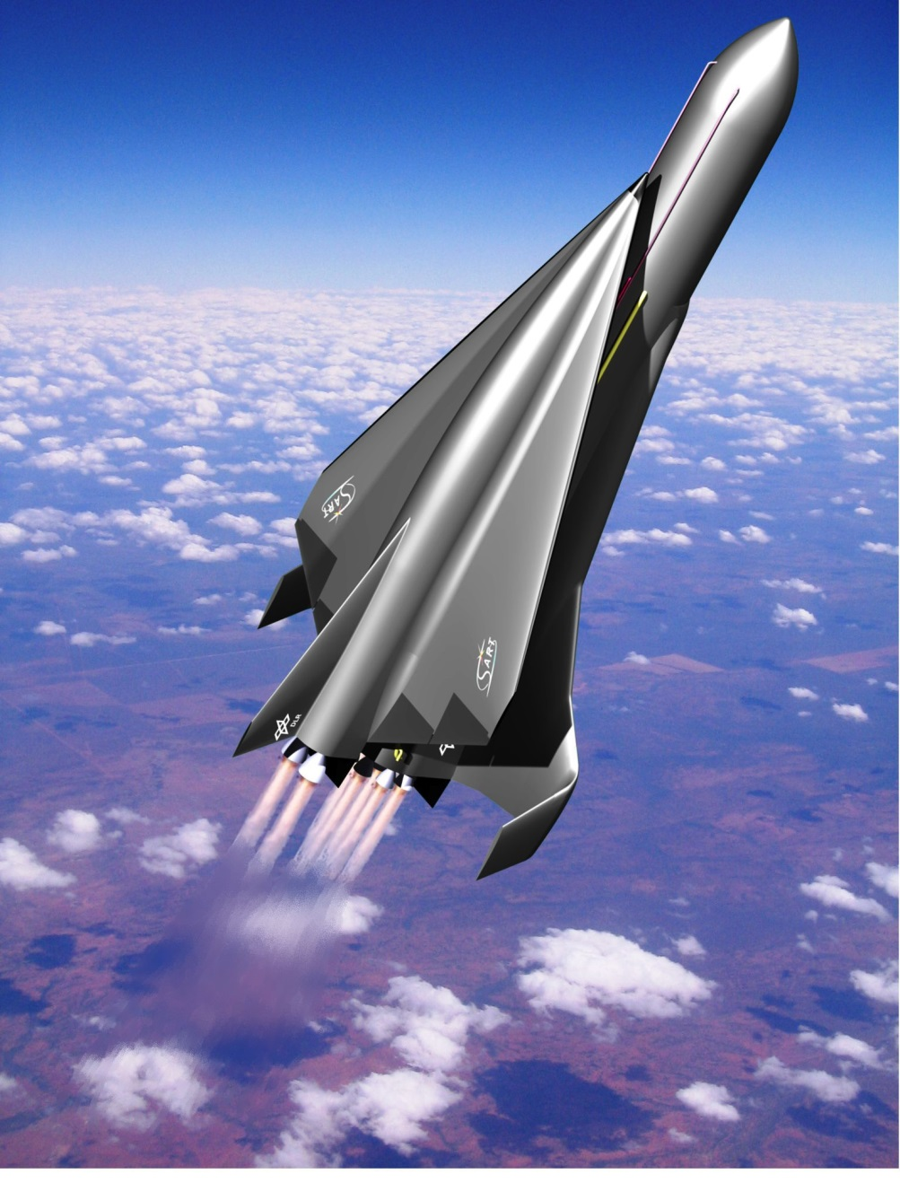

Page intentionally left blank.

**Deutsches Zentrum für Luft- und Raumfahrt e.V.**



**SART TN-003/2018**

Jascha Wilken

SpaceLiner System Specification Document

**SL-SS-SART-00026-1/1**

This report contains:

26 pages including

3 Figures

- Tables

32 References

**Deutsches Zentrum für Luft- und Raumfahrt e.V.**

**Institut für Raumfahrtsysteme**

**Systemanalyse Raumtransport (SART)**

**28359 Bremen**

**Document Control Sheet 1:**

|  |  |  |  |  |  |  |
| --- | --- | --- | --- | --- | --- | --- |
| **Issuing Organization:**  D:\Projekte\SART\SART_Logolores.jpg **Systemanalyse Raumtransport (SART)** | |  | **Classification:**   1. Public 2. Industry / Partners 3. Restricted 4. Confidential | | | **2** |
| **Document No. with Issue and Revision**  **SL-SS-SART-00026-1/1** | | | **Contractual**  **No** | |  | |
| **Title:**  **SpaceLiner System Specification Document** | | | | | | |
| **AUTHOR(S):** | Jascha Wilken  Leonid Bussler | | **Visa:** |  | | |
| **Contributing AUTHOR(S):** | Sholto Forbes-Spyratos | |  | |  | |
| **DATE OF ISSUE**  **23/05/2017** | **INTERNAL DOCUMENT NUMBER**  SART TN-003/2018 | |  | | **Total number of pages: 37 (including appendices)**  **Nb. of appendices: 0** | |
| **AUTHOR'S ABSTRACT:**  This document is the System Specification document for the SpaceLiner Program. It provides top-level information with regard to the technical elements, gives definitions of all major elements, and refers to applicable and reference documents. | | | | | | |
| **Keywords:** | SpaceLiner, SSD | | | | | |
| **Approved by:** | Martin Sippel | | **Visa:** |  | | |

**Document Control Sheet 2:**

|  |  |  |  |  |  |
| --- | --- | --- | --- | --- | --- |
|  | **Distribution List** | | **SL-SS-SART-00026-1/1** | |  |
| **INTERNAL DISTRIBUTION** | | | | | |
| **NAMES**  **(Optional)** | | **ORGANIZATION or DEPARTMENT**  **ABBREVIATION** | **Number of copies** | **Action**  Approve  Acceptance  Information  Other | |
|  | | **DLR-SART** | **1** | Information | |
|  | |  |  |  | |
| **EXTERNAL DISTRIBUTION** | | | | | |
| **NAMES**  **(Optional)** | | **ORGANIZATION or DEPARTMENT**  **ABBREVIATION** | **Number of copies** | **Action**  Approve  Acceptance  Information  Other | |

**Document Control Sheet 3:**

|  |  |  |  |  |  |  |
| --- | --- | --- | --- | --- | --- | --- |
|  | **ISSUE AND REVISION STATUS** | | | **SL-SS-SART-00026-1/1** | |  |
| **Issue and**  **Revision No.:** | | **Date of Issue**  **and Revisions:** | **Page numbers Changed or Added:** | | **Description:** | |
| draft | |  | N/A | | first internal draft | |
|  | |  |  | | Additional trajectory options investigated | |

**Table of Contents**

1 INTRODUCTION 1

1.1 Preamble 1

1.2 Objective 1

2 APPLICABLE & REFERENCE DOCUMENTS 1

2.1 Applicable Documents 1

2.2 Reference Documents 2

2.3 SpaceLiner Documents 2

DEFINITIONS & ACRONYMS 3

2.4 Definitions 3

2.5 Nomenclature 4

2.6 Acronyms 5

3 System Description 6

3.1 Configurations 6

3.1.1 PAX 6

3.1.2 TSTO 6

3.2 SpaceLiner Orbiter stage 6

3.3 SpaceLiner Passenger stage 7

3.3.1 Passenger capsule 7

3.4 SpaceLiner Booster 7

4 Mass model and breakdown 8

4.1 PAX 8

4.2 TSTO 12

5 Nominal trajectories 17

5.1 PAX 17

5.1.1 Ascent Trajectory 17

5.1.2 Orbiter Descent Trajectory 18

5.1.3 Booster Descent Trajectory 19

5.2 TSTO 21

5.2.1 Ascent Trajectory 22

5.2.2 Ballistic Trajectory 23

5.2.3 Upper Stage Trajectory 23

5.2.4 Orbiter Descent Trajectory 24

5.2.5 Booster Descent Trajectory 26

5.2.5.1 Thermal Protection System Design 27

5.2.5.2 Nonmetallic TPS 29

5.2.5.3 Metallic TPS 30

6 Description of subsystems 32

# INTRODUCTION

## Preamble

The SpaceLiner program ‎[RD-1], ‎[RD-2] is an initiative of DLR’s Space Launcher System Analysis (SART) group. The overall goal is to develop, produce, implement and operate (bringing into use) a new generation high-speed-long-distance reusable, hypersonic, intercontinental, point-to-point, passenger transportation system based on reusable rocket-propulsion stages. The main aim of this vehicle is to provide passengers with a reliable, safe and affordable connection between continents. Figure ‎1‑1 shows an impression of how the staging process of the most recent SpaceLiner configuration 7 would look like. The shown concept represents the current status of pre-development but should in no way anticipate final design solutions achieved throughout evolution of the actual development process.

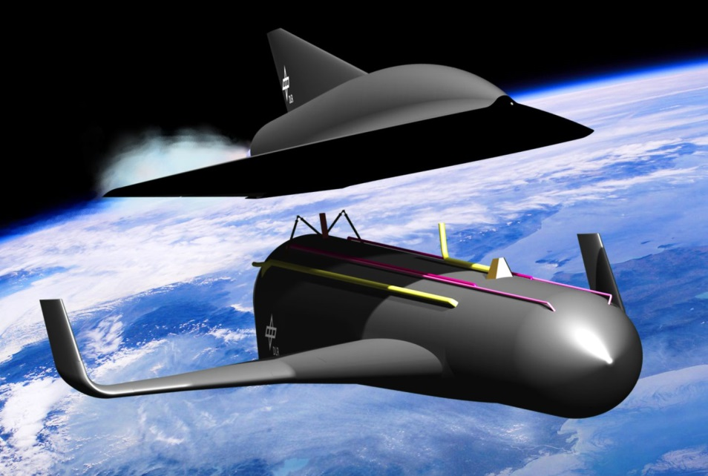

Figure ‎1‑1: Artist’s impression of SpaceLiner 7 configuration at stage separation

## Objective

This document, referred to as “System Specification Document” documents the current specifications of the architecture chosen for the SpaceLiner System (SLS) to fulfill the requirements given in the “Mission Requirements Document (MRD)”. Since the SpaceLiner Program is currently in Phase A, this only constitutes a preliminary description and will only be finalized within Phase B.

# APPLICABLE & REFERENCE DOCUMENTS

## Applicable Documents

The SpaceLiner program must be in full agreement with international regulations and national laws of all participating nations. However, specific binding regulations for the operation of high-speed passenger transport vehicles operating at the edge of space do not yet exist in a similar way as for all kinds of manned and unmanned aviation. Nevertheless, a safety standard is in the preparation process which might become applicable to the SpaceLiner Program. The most recent publication is found in:

1. IAASS-ISSB-S-1700-Rev-B, International Association for the Advancement of Space Safety - Space Safety Standard (Commercial Human-Rated System), March 2010, published also in Journal of Space Safety Engineering – Vol. 3, No. 1 - April 2016

## Reference Documents

The following documents are reference documents for, or related matters of the SpaceLiner System (SLS), and are applicable to the extent as defined in this System Specification Document (SSD):

1. Sippel, M.: SpaceLiner Development Roadmap and Technology&Research Requirements, SART TN-014/2014, V1, May 2015
2. Sippel, M.; Schwanekamp, T.; Trivailo, O.; Kopp, A.; Bauer, C.; Garbers, N.: SpaceLiner Technical Progress and Mission Definition, AIAA 2015-3582, 20th AIAA International Space Planes and Hypersonic Systems and Technologies Conference, Glasgow, ch. 1-4, July 2015
3. E. Casali; L. Bussler; M. Sippel, Investigation of feasible flight trajectories and re-entry atmospheric guidance for SpaceLiner 7, SART TN-014/2015, Deutsches Zentrum für Luft- und Raumfahrt, Germany, 2016
4. Garbers, N.: Latest Version of SpaceLiner’s TPS with TOP, SART TN-026/2013, DLR, 2013
5. Sippel, M.; Schwanekamp, T.: The SpaceLiner Hypersonic System – Aerothermodynamic Requirements and Design Process, SART-Paper, 2015
6. Myers, D.E.; Carl, J.M.; Blosser, M.L.: Parametric Weight Comparison of Advanced Metallic, Ceramic Tile, and Ceramic Blanket Thermal Protection Systems, NASA, June 2008

## SpaceLiner Documents

1. SpaceLiner Mission Requirements Document, SL-MR-SART-00001-1/2
2. SpaceLiner System Specification Document, SL-SS-SART-00026-1/0
3. SpaceLiner Subsystem Specification Document: Propellant Supply System, SL-SSS-PSS-SART-00039-1/0
4. AEDB SL7-2, SL-SS-AEDB-SART-00037-1/0, Schwanekamp, T.; Morsa, L.; Zuppardi, G.; Molina, R.: SpaceLiner 7-2 Aerodynamic Reference Database, SART TN-026/2012, DLR, 2012
5. SpaceLiner Subsystem Specification Document: SLME System Specification, SL-SSS-SLME-SART-00040-1/0

# DEFINITIONS & ACRONYMS

## Definitions

See Figure ‎0‑1 for a visual representation of the association and relation between the various SpaceLiner elements defined as follows:

|  |  |
| --- | --- |
| **DEF- 1: SpaceLiner Program**  *Refers to the entire SpaceLiner undertaking including space and ground segments and all elements of the Work Breakdown Structure (WBS) over the full life-cycle. The term “Program” shall be used at level 1 of the WBS and it shall also summarize projects at lower WBS levels.* | |
| **DEF- 2: SpaceLiner Project**  *Refers to the development project of the SpaceLiner System (SLS) from Phase A through Phase D according to the Master Schedule shown in [SLD-1].* | |
| **DEF- 3: SpaceLiner System (SLS)**  *Refers to the SLS, which includes the SpaceLiner Vehicle (SLV), as well as the SpaceLiner Ground Segment (SLGS).* | |
| **DEF- 4: SpaceLiner Vehicle (SLV)**  *Refers to the SLV. For the SpaceLiner passenger (PAX) version, this includes the SpaceLiner Booster (SLB) and the SpaceLiner Passenger Stage (SLP). For the SpaceLiner orbital version, this includes the SLB and the SpaceLiner Orbiter stage (SLO).* | |
| **DEF- 5: SpaceLiner Ground Segment (SLGS)**  *Refers to all launch and landing site (L/L) ground infrastructure, as well as maintenance and passenger commuting networks, communication infrastructure, and dedicated rescue infrastructure.* | |
| **DEF- 6: SpaceLiner Booster stage (SLB)**  *Refers to the entire SLB, including main engines (SLME).* | |
| **DEF- 7: SpaceLiner Passenger stage (SLP)**  *Refers to the SpaceLiner passenger stage, including the passenger cabin (SLC) and main engines (SLME).* | |
| **DEF- 8: SpaceLiner Orbiter stage (SLO)**  *Refers to the SLO capable of deploying payload in orbit, including SLME* | |
| **DEF- 9: SpaceLiner main engine (SLME)**  *Refers to the SLME, which is used in the SLB, SLP and SLO stages.* | |
| **DEF- 10: SpaceLiner passenger Cabin (SLC)**  *Refers to the SLC for the SpaceLiner PAX version.* | |
| **DEF- 11: Mission Phase**  *Refers to the SLV flight and ground phases.* | |
| **DEF- 12: Flight Phase**  *Refers to the SLV (PAX version) during:*   * *mated ascent* * *SLP ascent* * *SLB descent & return to landing site* * *SLP descent & landing* | *Refers to the SLV (orbital version) during:*   * *mated ascent* * *SLO ascent* * *SLB descent & return to landing site* * *SLO orbital phase* * *SLO re-entry & landing* |
| **DEF- 13: Ground Phase**  *Refers to all SLV ground transportation, including the air transportation mode, maintenance, and launch preparation.* | |
| **DEF- 14: Air transportation mode**  *Refers to any transportation of complete but inactive SLV components performed via air.* | |
| **DEF- 15: Launch preparation**  *Refers to propellant feed, passenger boarding and SLC pre-flight integration into SLP.* | |
| **DEF- 16: Passenger**  *Refers to a common civilian passenger.* | |
| **DEF- 17: Turnaround period**  *Refers to the time between SLV landing and vehicle readiness to take off for the next flight.* | |
| **DEF- 18: reusable**  *Refers to multiple reuses, with the quantity of possible reuses specific to the element/stage being described.* | |
| **DEF- 19**: **mission success**  Refers to the safe transportation of passengers over an intercontinental distance to the nominal destination point, being the nominal SLV landing site. | |
| **DEF- 20: inhabited area**  Refers to areas inhabited by more than **10 (TBC in Phase A)** permanent residents per km2. | |

Two different SLV versions exist. The PAX version is the point-to-point ultra-fast passenger transport vehicle - consisting of the SLB and SLP (which includes the SLC), and also inclusive of the SLME. The orbital version represents the SLB and SLO, also including the SLME and shall function as an orbital transport system used for transportation of payloads to and from orbit.



Figure ‎0‑1: A visual representation of the association and relation between the various SpaceLiner System elements

## Nomenclature

|  |  |  |
| --- | --- | --- |
| nx | load factor in axial direction | g |
| nz | load factor in vertical direction | g |

## Acronyms

|  |  |
| --- | --- |
| AD  LCC  LEO  L/L  MPS  MR  MRD  PAX  RD  SI  SLB  SLC  SLGS  SLME  SLO  SLP  SLS  SLV  SRR  TBC  TBD  TSTO | Applicable Document  Life Cycle Cost  Low Earth Orbit  Launch / Landing  Master Program Schedule  Mission Requirements  Mission Requirements Document  Passengers  Reference Document  Système International (Metrical Units System)  SpaceLiner Booster stage  SpaceLiner Cabin  SpaceLiner Ground Segment  SpaceLiner Main Engine  SpaceLiner Orbiter stage  SpaceLiner Passenger stage  SpaceLiner System  SpaceLiner Vehicle  System Requirements Review  To Be Confirmed  To Be Defined  Two Stage To Orbit |

# 

# System Description

The key premise behind the original concept inception is that the SpaceLiner ultimately has the potential to enable sustainable low-cost space transportation to orbit while at the same time revolutionizing ultra-long distance travel between different points on Earth. The number of launches per year should be strongly raised and hence manufacturing and operating cost of launcher hardware should dramatically shrink.

Ultra-long distance travel from one major business center of the world to another major agglomeration on Earth is a huge and mature market. An interesting alternative to air-breathing hypersonic passenger airliners in the field of future high-speed intercontinental passenger transport vehicles might be a rocket-propelled, suborbital craft. Such a new kind of ‘space tourism’ based on a two stage RLV has been proposed by DLR under the name **SpaceLiner**. Ultra-long-haul distances like Europe – Australia could be flown in 90 minutes. Another interesting intercontinental destination between Europe and North-West America could be reduced to flight times of slightly more than one hour. The fast intercontinental travel space tourism, not only attracting the leisure market, would, as a byproduct, also enable to considerably reduce the cost of space transportation to orbit.

Different configurations in terms of propellant combinations, staging, aerodynamic shapes, and structural architectures have been analyzed.

The general baseline design concept consists of a fully reusable booster and passenger stage arranged in parallel. All rocket engines should work from lift-off until MECO. A propellant crossfeed from the booster to the passenger stage (also called orbiter) is foreseen up to separation to reduce the overall size of the configuration. In total nine SLME’s with shortened nozzles are installed on the booster stage while two SLME’s with larger nozzles are installed on the upper stage.

## Configurations

### PAX

The SpaceLiner PAX configuration is the original concept and the baseline for any derivatives such as the TSTO configuration. The objective is to transport 50 passengers on ultra-long distances at hypersonic speeds in order to enable fast travel between major business centers of the world. The passengers are transported within a quasi-separate segment of the stage that doubles as an escape option. Five solid separation motors can propel the capsule to a safe distance while its aerodynamic shape, a body flap and a parachute system enable the capsule to safely abort and land from any point of the trajectory. This system was included in order to achieve the high safety required for frequent commercial transport of civilian passengers.

### TSTO

The SpaceLiner PAX configuration is an ideal technical basis for a two-stage fully reusable satellite launch vehicle, the SpaceLiner TSTO. The passenger transport reaches almost orbital speed at MECO during its reference mission. The baseline design of the orbital launcher remains unchanged to the passenger version with a fully reusable booster and orbiter stage arranged in parallel and the external shapes will be very similar. The booster should be identical to the booster of the PAX configuration. This approach intends to enable dramatic savings on development cost and moreover by manufacturing the vehicles on the same production line, and also through significantly lower hardware cost than would result for a dedicated new lay-out.

## SpaceLiner Orbiter stage

The core purpose of the upper stage of the TSTO configuration is to deliver a kickstage including the final payload into an orbit that allows the kickstage to place the satellite into the final orbital destination. In practical terms this means it is released into a 30 km x 250 km orbit. Once the payload is deposited, the orbiter reenters the atmosphere and autonomously glides to the designated landing site using its wings. The reference GTO mission even allows it to return to its launch site in Kourou. It should be noted that while all other components of the SLS are reusable, the kickstage is not designed to be reusable. The reentry results in considerable heat loads which have to be handled by a sophisticated Thermal Protection System which includes active cooling with water.

## SpaceLiner Passenger stage

The purpose of this stage is the delivery of the Passenger capsule including its contents to the designated destination anywhere on earth’s surface. In order to achieve the high range necessary for this, the stage uses its SLME’s to further accelerate after the separation from the booster stage. The passenger stage is able to accelerate up to near orbital speeds that allow it to reach its far off destination thanks to the aerodynamic properties of its winged shape. The reentry results in considerable heat loads which have to be handled by a sophisticated Thermal Protection System which includes active cooling with water. The requirements for the TPS are very similar for both configurations, so it is expected that the same TPS design can fulfill both missions.

### Passenger capsule

The Passenger Capsule is the pressurized container for the passengers and other cargo. It is intended that the passengers board while the capsule is separate from the second stage. After everything has been secured, the capsule is rotated and mated to the Passenger stage.

In the unlikely event of an emergency the capsule is ejected from the second stage by its five solid rocket motors. The ejection system is designed so that the capsule reaches a minimum safe distance even if the entire propellant stack explodes. However, the accelerations during the ejection are massive, so that the passengers should remain seated during the flight for their own safety.

Once the passenger stage lands, the capsule is separated once more in order to allow for an easy and quick disembarking.

## SpaceLiner Booster

The SpaceLiner Booster (SLB) functions as a first stage for either upper stage. During the joint flight it also provides the two SLME’s of the upper stage with propellant through a crossfeed system. In order to be reused the SLB is equipped with wings that allow it to reenter the earth’s atmosphere and to idle until a conventional aircraft captures and tows it back to the launch site where the SLB can land autonomously on a suitable landing strip. The propulsion of the SLB is provided by 9 SLME’s, all of which are equipped with the shorter nozzle.

# Mass model and breakdown

The following sections contain the high-level mass breakdown of the two SpaceLiner configurations. For more information of the details of the subsystem masses, refer to the subsystem documentation given in chapter ‎6.

## PAX

The following Table ‎4‑1 contains the mass breakdown of the SpaceLiner PAX configuration. **Please note that propellant masses given below are the actually loaded propellant masses of the respective stage.**

Table ‎4‑1: Mass breakdown of SpaceLiner PAX configuration

|  |  |  |
| --- | --- | --- |
| **Group** | **Component** | **Mass [kg]** |
| **Stage # 1** | | |
| **Structure** | Nose | 1957 |
| Hypersonic Vehicle Body (HASA) | 3673 |
| Bodyflap | 252 |
| LOX tank | 13238 |
| Intertank | 7170 |
| LH2\_Tank | 44497 |
| Landing Wing Structure | 20856 |
| Fins / Vertical Stabilizer | 1166 |
| Fins / Vertical Stabilizer | 1166 |
| Wing Control Flaps | 2352 |
| Thrustframe | 8953 |
| Fwd Stage Attachment | 1400 |
| Aft Stage Attachment | 1100 |
| Fwd Crossfeed Fairing | 250 |
| Aft Crossfeed Fairing | 250 |
| Mass Structure group: w/o margins | 108282 |
| Mass Structure group: including 14.0 % margins | 123441 |
|  | | |
| **Subsystems** | Engine Equipment | 1698 |
| LOX tank pressurization system | 580 |
| LH2 tank pressurization system | 450 |
| Undercarriage / Landing Gear | 6951 |
| Electrics | 3074 |
| Avionics | 300 |
| Hydraulics | 400 |
| ECS | 200 |
| Primary Power | 400 |
| Separation System | 2534 |
| Mass Subsystem group: w/o margins | 16587 |
| Mass Subsystem group: including 14.0 % margins | 18909 |
|  | | |
| **Propulsion** | Rocket Main Engines | 27864 |
| LOX Main Feedline | 2295 |
| LOX Manifold | 450 |
| LH2 Main Feedline | 195 |
| LH2 Manifold | 525 |
| LH2 Central Feedline | 52 |
| LOX Crossfeed Feedline | 484 |
| LH2 Crossfeed Feedline | 287 |
| LOX-Fill-Drain-Dump-line | 95 |
| LH2-Fill-Drain-Dump-line | 118 |
| RCS Engines | 584 |
| Mass Propulsion group: w/o margins | 32948 |
| Mass Propulsion group: including 12.0 % margins | 36902 |
|  | | |
| **Thermal protection** | TPS FRSI 401-500K | 2571 |
| TPS FRSI 501-600K | 1254 |
| TPS AFRSI 601-700K | 1197 |
| TPS AFRSI 701-800K | 912 |
| TPS AFRSI 801-900K | 804 |
| TPS TABI 901-1000K | 1118 |
| TPS TABI 1001-1100K | 1625 |
| TPS TABI 1101-1200K | 319 |
| TPS TABI 1201-1300K | 1141 |
| TPS TABI 1301-1400K | 722 |
| TPS TABI 1401-1500K | 292 |
| TPS TABI 1501-1600K | 116 |
| TPS CMC 1601-1700K | 1797 |
| TPS CMC 1701-1850K | 8 |
| Cryogenic Insulation | 450 |
| Cryogenic Insulation | 2431 |
| Mass Thermal Protection group: w/o margins | 16759 |
| Mass Thermal Protection group: including 14.0 % margins | 19106 |
|  | | |
| **Stage masses** | Stage Mass empty: (stage coordinates) | 174576 |
| Stage Mass empty incl.marg.: (global coordinates) | 198358 |
| Stage Structural Index: | 0,1564 |
|  |  |
| Orbit/De-orbit propellant: | 500 |
| Residual propellant: | 9515 |
| Reserve propellant: | 4246 |
|  |  |
| Stage Mass @ burn out: | 212619 |
|  |  |
| RCS propell. /inert flow mass: | 0 |
| Ascent propellant: | 1254155 |
|  |  |
| GLOW Stage Mass: | 1466774 |
| **Stage # 2** | | |
| **Structure** | Hypersonic Vehicle Body (HASA) | 14487 |
| LOX tank (WAATS) | 3283 |
| Tank | 4419 |
| Landing Wing Structure | 18336 |
| Fins / Vertical Stabilizer | 3989 |
| Wing Control Flaps | 1814 |
| Bodyflap | 304 |
| Thrust Frame Rocket Engines | 1008 |
| Launch Table Support | 870 |
| Mass Structure group: w/o margins | 48510 |
| Mass Structure group: including 14.0 % margins | 55301 |
|  | | |
| **Subsystems** | Engine Equipment | 443 |
| LOX tank pressurization system | 195 |
| LH2 tank pressurization system | 155 |
| Electrics | 2216 |
| Hydraulics | 300 |
| Primary Power | 400 |
| Main Gear | 3300 |
| Nose Gear | 585 |
| Cabin incl. Passengers | 29868 |
| Capsule Separation Motors | 3070 |
| Radiators Heat Control | 500 |
| Nose Water Tank + Cooling | 140 |
| Left Wing Water Tank | 160 |
| Right Wing Water Tank | 160 |
| Mass Subsystem group: w/o margins | 40993 |
| Mass Subsystem group: including 14.0 % margins | 46732 |
|  | | |
| **Propulsion** | Rocket Main Engines | 6750 |
| LOX Crossfeed Line | 285 |
| LOX Main feedline | 510 |
| LOX Manifold | 120 |
| LH2 Main Feedline | 177 |
| LH2 Manifold Line | 105 |
| LH2 Crossfeed Line | 265 |
| LOX-Fill-Drain-Dump-line | 75 |
| LH2-Fill-Drain-Dump-line | 76 |
| RCS Engines | 275 |
| Mass Propulsion group: w/o margins | 8637 |
| Mass Propulsion group: including 12.0 % margins | 9674 |
|  | | |
| **Thermal protection** | Cryogenic Insulation | 584 |
| Cryogenic Insulation | 235 |
| Metallic TPS | 17790 |
| FRSI T<=600K | 716 |
| AFRSI(530K) 601K<=T<=700K Wing/Body | 957 |
| AFRSI(530K) 601K<=T<=700K Fin | 190 |
| AFRSI(530K) 701K<=T<=800K Wing/Body | 1594 |
| AFRSI(530K) 701K<=T<=800K Fin | 564 |
| AFRSI(530K) 801K<=T<=900K Wing/Body | 511 |
| AFRSI(530K) 801K<=T<=900K Fin | 122 |
| Haynes 230 (530K) 901K<=T<=1000K | 1030 |
| Haynes 230 (530K) 901K<=T<=1000K | 19 |
| Haynes 230 (530K) 1001K<=T<=1100K | 531 |
| Haynes 230 (530K) 1001K<=T<=1100K | 25 |
| Haynes 230 (530K) 1101K<=T<=1200K | 1594 |
| Haynes 230 (530K) 1101K<=T<=1200K | 2 |
| TABI(530K) 1201K<=T<=1300K | 1303 |
| TABI(530K) 1301K<=T<=1400K | 4527 |
| AETB-12(530K) 1401K<=T<=1500K | 2721 |
| AETB-12(530K) 1501K<=T<=1600K | 837 |
| CMC(530K) 1601K<=T<=1700K | 342 |
| CMC(530K) 1701K<=T<=1850K | 205 |
| Active TPS leading edge | 680 |
| Active TPS nose | 25 |
| Active TPS margin | 250 |
| Mass Thermal protection group: w/o margins | 19564 |
| Mass Thermal protection group: including 14.0 % margins | 22303 |
|  | | |
| **Stage masses** | Stage Mass empty: (stage coordinates) | 117704 |
| Stage Mass empty incl.marg.: (global coordinates) | 134010 |
| Stage Structural Index: | 0,5791 |
|  |  |
| Orbit/De-orbit propellant: | 12800 |
| Residual propellant: | 3203 |
| Reserve propellant: | 1191 |
|  |  |
| Stage Mass @ burn out (fairing separated): | 151205 |
|  |  |
| RCS propell. /inert flow mass: | 0 |
| Ascent propellant: | 214201 |
|  |  |
| GLOW Stage Mass (w/o payload): | 365406 |
|  | | |
| **Total vehicle masses** | Total Vehicle Mass empty: | 292280 |
| Vehicle Mass empty incl. margins: | 332368 |
| Total Lift-off Mass: | 1832179 |
|  |  |
| Gross Lift-Off Mass: | 1832179 |

## TSTO

The following Table ‎4‑2 contains the mass breakdown for the TSTO configuration. **Please note that propellant masses given below are the actually loaded propellant masses of the respective stage.**

Table ‎4‑2: Mass breakdown of SpeceLiner TSTO configuration

|  |  |  |
| --- | --- | --- |
| **Group** | **Component** | **Mass [kg]** |
| **Stage # 1** | | |
| **Structure** | Nose | 1957 |
| Hypersonic Vehicle Body (HASA) | 3673 |
| Bodyflap | 252 |
| LOX tank | 13238 |
| Intertank | 7170 |
| LH2\_Tank | 44499 |
| Landing Wing Structure | 20457 |
| Fins / Vertical Stabilizer | 1166 |
| Fins / Vertical Stabilizer | 1166 |
| Wing Control Flaps | 2306 |
| Thrustframe | 8953 |
| Fwd Stage Attachment | 1400 |
| Aft Stage Attachment | 1100 |
| Fwd Crossfeed Fairing | 250 |
| Aft Crossfeed Fairing | 250 |
| Mass Structure group: w/o margins | 107836 |
| Mass Structure group: including 14.0 % margins | 122933 |
|  | | |
| **Subsystems** | Engine Equipment | 1698 |
| LOX tank pressurization system | 580 |
| LH2 tank pressurization system | 450 |
| Undercarriage / Landing Gear | 6669 |
| Electrics | 3001 |
| Avionics | 300 |
| Hydraulics | 400 |
| ECS | 200 |
| Primary Power | 400 |
| Separation System | 2452 |
| Mass Subsystem group: w/o margins | 16150 |
| Mass Subsystem group: including 14.0 % margins | 18411 |
|  | | |
| **Propulsion** | Rocket Main Engines | 27864 |
| LOX Main Feedline | 2295 |
| LOX Manifold | 450 |
| LH2 Main Feedline | 195 |
| LH2 Manifold | 525 |
| LH2 Central Feedline | 52 |
| LOX Crossfeed Feedline | 484 |
| LH2 Crossfeed Feedline | 287 |
| LOX-Fill-Drain-Dump-line | 95 |
| LH2-Fill-Drain-Dump-line | 118 |
| RCS Engines | 584 |
| Mass Propulsion group: w/o margins | 32948 |
| Mass Propulsion group: including 12.0 % margins | 36902 |
|  | | |
| **Thermal protection** | TPS FRSI 401-500K | 2571 |
| TPS FRSI 501-600K | 1254 |
| TPS AFRSI 601-700K | 1197 |
| TPS AFRSI 701-800K | 912 |
| TPS AFRSI 801-900K | 804 |
| TPS TABI 901-1000K | 1118 |
| TPS TABI 1001-1100K | 1625 |
| TPS TABI 1101-1200K | 319 |
| TPS TABI 1201-1300K | 1141 |
| TPS TABI 1301-1400K | 722 |
| TPS TABI 1401-1500K | 292 |
| TPS TABI 1501-1600K | 116 |
| TPS CMC 1601-1700K | 1797 |
| TPS CMC 1701-1850K | 8 |
| Cryogenic Insulation | 450 |
| Cryogenic Insulation | 2431 |
| Mass Thermal Protection group: w/o margins | 16759 |
| Mass Thermal Protection group: including 14.0 % margins | 19106 |
|  | | |
| **Stage masses** | Stage Mass empty: (stage coordinates) | 173694 |
| Stage Mass empty incl.marg.: (global coordinates) | 197352 |
| Stage Structural Index: | 0,1543 |
|  |  |
| Orbit/De-orbit propellant: | 0 |
| Residual propellant: | 9000 |
| Reserve propellant: | 0 |
|  |  |
| Stage Mass @ burn out: | 206352 |
|  |  |
| RCS propell. /inert flow mass: | 0 |
| Ascent propellant: | 1269935 |
|  |  |
| GLOW Stage Mass: | 1476287 |
| **Stage # 2** | | |
| **Structure** | Hypersonic Vehicle Body (HASA) | 14487 |
| LOX tank (WAATS) | 2970 |
| Tank | 4419 |
| Landing Wing Structure | 18329 |
| Fins / Vertical Stabilizer | 3989 |
| Wing Control Flaps | 1814 |
| Bodyflap | 304 |
| Thrust Frame Rocket Engines | 1008 |
| Launch Table Support | 870 |
| Payload Bay | 3500 |
| Payload Provision | 1000 |
| Mass Structure group: w/o margins | 52690 |
| Mass Structure group: including 14.0 % margins | 60066 |
|  | | |
| **Subsystems** | Engine Equipment | 443 |
| LOX tank pressurization system | 195 |
| LH2 tank pressurization system | 155 |
| Electrics | 2215 |
| Hydraulics | 300 |
| Primary Power | 400 |
| Main Gear | 3300 |
| Nose Gear | 585 |
| Radiators Heat Control | 500 |
| Nose Water Tank + Cooling | 140 |
| Left Wing Water Tank | 160 |
| Right Wing Water Tank | 160 |
| Mass Subsystem group: w/o margins | 8553 |
| Mass Subsystem group: including 14.0 % margins | 9751 |
|  | | |
| **Propulsion** | Rocket Main Engines | 6750 |
| LOX Crossfeed Line | 285 |
| LOX Main feedline | 510 |
| LOX Fwd Feedline | 210 |
| LOX Manifold | 120 |
| LH2 Main Feedline | 177 |
| LH2 Manifold Line | 105 |
| LH2 Crossfeed Line | 265 |
| LOX-Fill-Drain-Dump-line | 75 |
| LH2-Fill-Drain-Dump-line | 76 |
| RCS Engines | 275 |
| Mass Propulsion group: w/o margins | 8848 |
| Mass Propulsion group: including 12.0 % margins | 9909 |
|  | | |
| **Thermal protection** | Cryogenic Insulation | 584 |
| Cryogenic Insulation | 235 |
| Metallic TPS | 17790 |
| FRSI T<=600K | 716 |
| AFRSI(530K) 601K<=T<=700K Wing/Body | 957 |
| AFRSI(530K) 601K<=T<=700K Fin | 190 |
| AFRSI(530K) 701K<=T<=800K Wing/Body | 1594 |
| AFRSI(530K) 701K<=T<=800K Fin | 564 |
| AFRSI(530K) 801K<=T<=900K Wing/Body | 511 |
| AFRSI(530K) 801K<=T<=900K Fin | 122 |
| Haynes 230 (530K) 901K<=T<=1000K | 1030 |
| Haynes 230 (530K) 901K<=T<=1000K | 19 |
| Haynes 230 (530K) 1001K<=T<=1100K | 531 |
| Haynes 230 (530K) 1001K<=T<=1100K | 25 |
| Haynes 230 (530K) 1101K<=T<=1200K | 1594 |
| Haynes 230 (530K) 1101K<=T<=1200K | 2 |
| TABI(530K) 1201K<=T<=1300K | 1303 |
| TABI(530K) 1301K<=T<=1400K | 4527 |
| AETB-12(530K) 1401K<=T<=1500K | 2721 |
| AETB-12(530K) 1501K<=T<=1600K | 837 |
| CMC(530K) 1601K<=T<=1700K | 342 |
| CMC(530K) 1701K<=T<=1850K | 205 |
| Active TPS leading edge | 680 |
| Active TPS nose | 25 |
| Active TPS margin | 250 |
| Mass Thermalprotection group:w/o margins | 19564 |
| Mass Thermalprotection group:including 14.0 % margins | 22303 |
|  | | |
| **Stage masses** | Stage Mass empty: (stage coordinates) | 89655 |
| Stage Mass empty incl.marg.: (global coordinates) | 102029 |
| Stage Structural Index: | 0,4989 |
|  |  |
| Orbit/De-orbit propellant: | 12800 |
| Residual propellant: | 2000 |
| Reserve propellant: | 0 |
|  |  |
| Stage Mass @ burn out (fairing separated): | 116829 |
| Payload Mass: | 28777 |
|  |  |
| RCS propell. /inert flow mass: | 0 |
| Ascent propellant: | 189712 |
|  |  |
| GLOW Stage Mass (w/o payload): | 306541 |
|  | | |
| **Total vehicle masses** | Total Vehicle Mass empty: | 263348 |
| Vehicle Mass empty incl. margins: | 299381 |
| Total Lift-off Mass: | 1782828 |
| Payload Mass of stage 2 : | 28777 |
|  |  |
| Gross Lift-Off Mass: | 1811605 |

# Nominal trajectories

## PAX

Different trajectory options and a number of off-nominal cases were investigated within ‎[RD-1]. The following figures merely describe the nominal reference mission from Australia to Northern Europe. The throttling procedure can be clearly seen in the acceleration and thrust profiles for the ascent. The SpaceLiner is throttled in order to increase passenger comfort. The final phase of the ascent is adjusted by hand in order to minimize oscillations within the descent trajectory. However, neither phase has been numerically optimized which is an implicit performance reserve.

### Ascent Trajectory

AllSep1

Figure ‎5‑1: Reference ascent trajectory for the SpaceLiner PAX configuration. Part 1/2

AllSep2

Figure ‎5‑2: Reference ascent trajectory for the SpaceLiner PAX configuration. Part 2/2

### Orbiter Descent Trajectory



Figure ‎5‑3: Reference descent trajectory of the passenger stage of the SpaceLiner PAX configuration. Part 1/2

AllSep2

Figure ‎5‑4: Reference descent trajectory of the passenger stage of the SpaceLiner PAX configuration. Part 2/2

### Booster Descent Trajectory

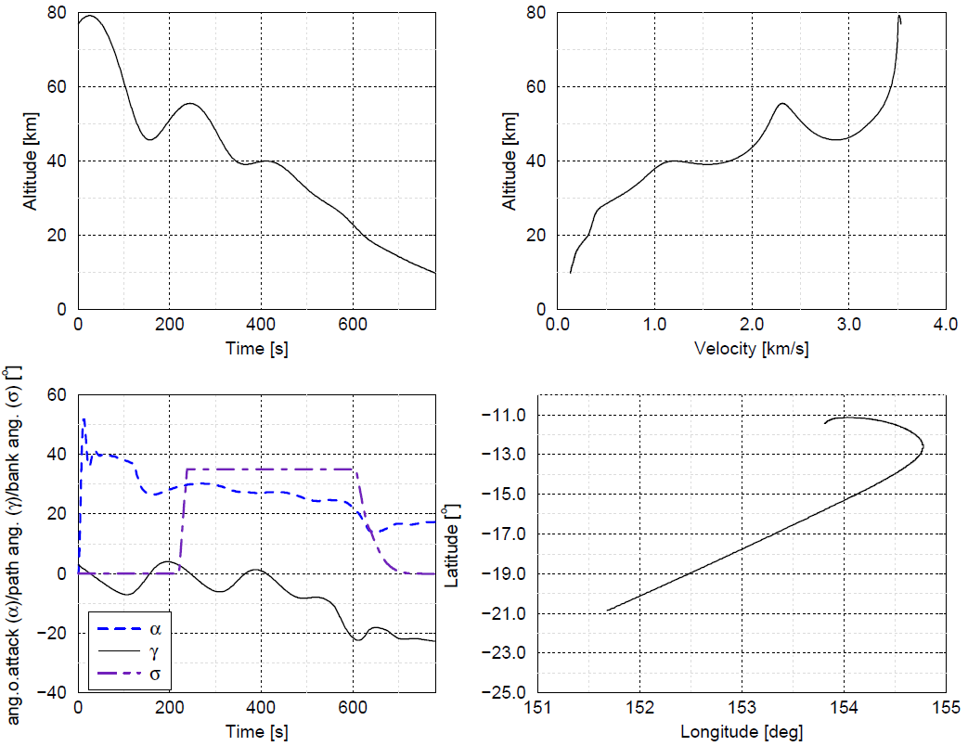

Figure ‎5‑5: PAX booster descent trajectory

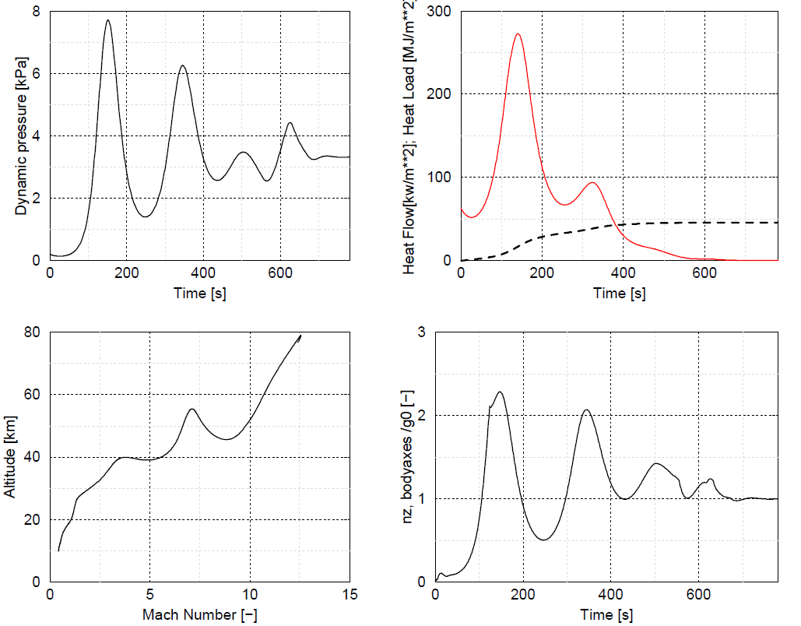

Figure ‎5‑6: PAX booster descent trajectory

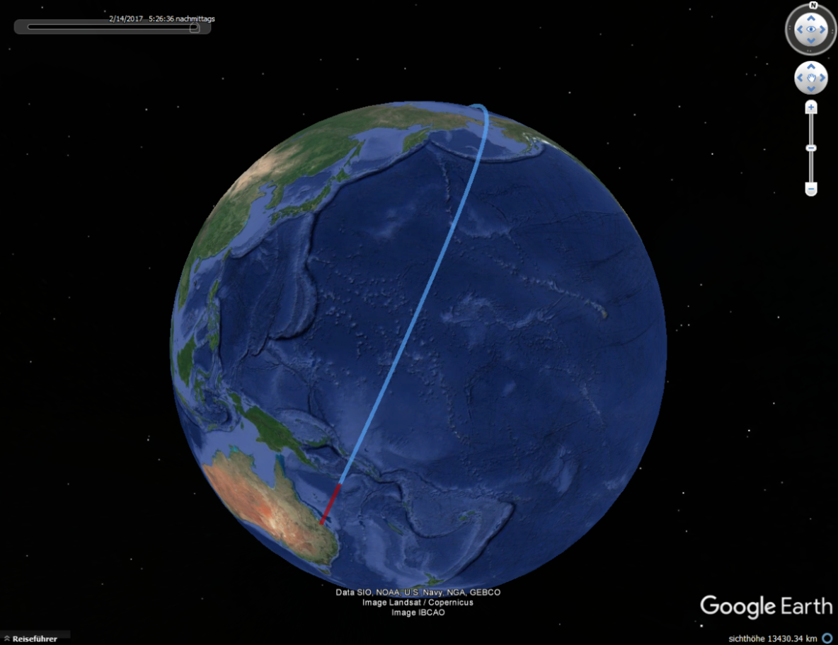

Figure ‎5‑7: Ascent (red) and first portion of descent (blue) trajectory of the reference mission of the SpaceLiner PAX configuration.

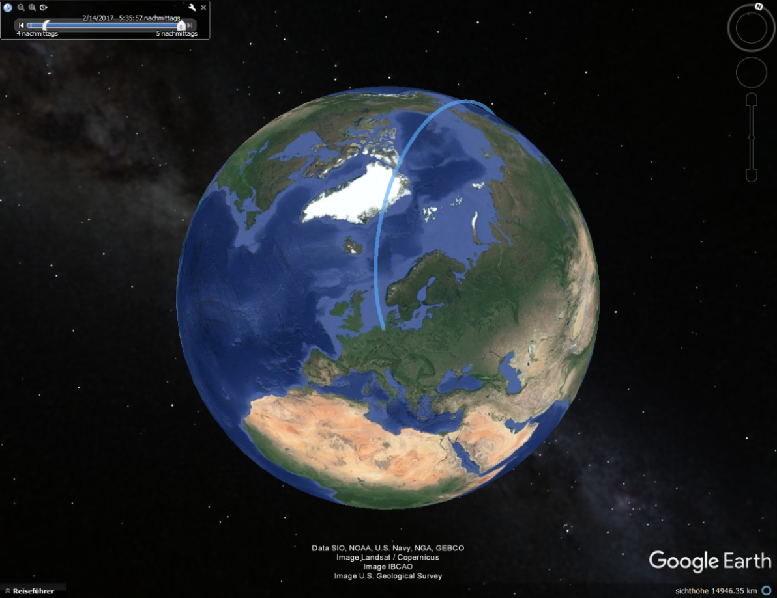

Figure ‎5‑8: Final portion of the descent trajectory of the reference mission for the SpaceLiner PAX configuration.

## TSTO

The SL TSTO configuration can deliver payloads to a number of different target orbits. Missions to GTO have been identified as promising. The launch site for all satellite delivery missions is Kourou, French Guyana.

On the GTO mission mated ascent is followed by booster separation at 70 km altitude and 3.8 km/s earth relative speed. After reentry into the atmosphere and a turning maneuver the booster is in-air captured and towed back to the launch site as for the SL PAX configuration. The orbiter continues powered ascent to reach a 30 × 250 km orbit. Main engine cut-off is at 85 km altitude. Prior to separation of the upper stage and the geostationary satellite a ballistic trajectory is followed to reach apogee altitude at about 230 km altitude. After separation the upper stage begins its perigee raising maneuver to reach a 250 × 35786 km transfer orbit while the SpaceLiner orbiter stage reenters the atmosphere flying on a “once around the globe” trajectory towards Kourou. The trajectories for the different phases are shown in Figure ‎5‑9 - Figure ‎5‑15. The time is counted from the beginning of the respective phase, e.g. from lift-off for the mated ascent trajectory and booster separation for the booster descent trajectory.

The trajectories for the different phases of the SL TSTO GTO mission will be presented below.

### Ascent Trajectory

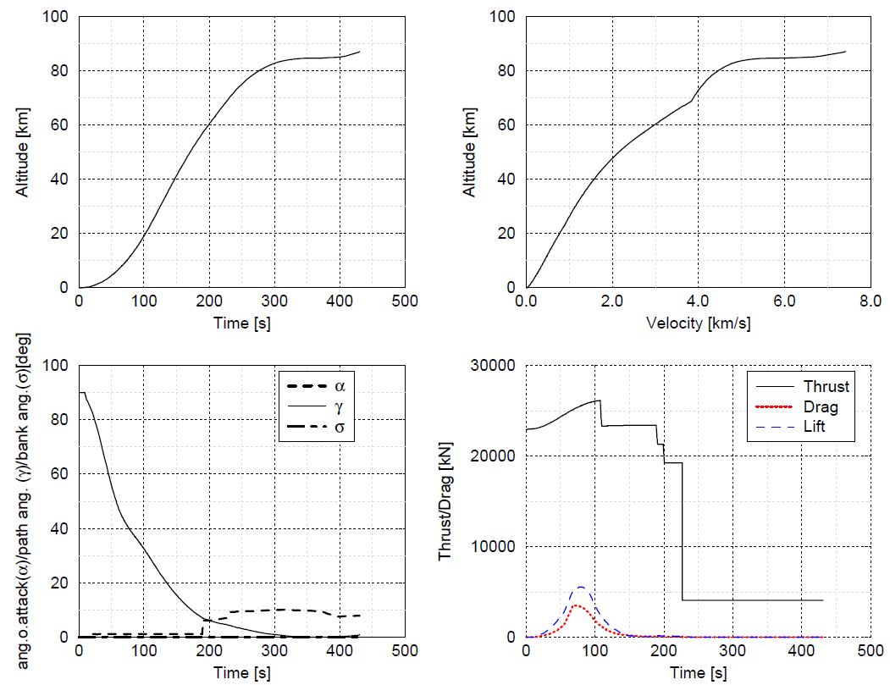

Figure ‎5‑9: Reference ascent trajectory for the SpaceLiner TSTO configuration. Part 1/2

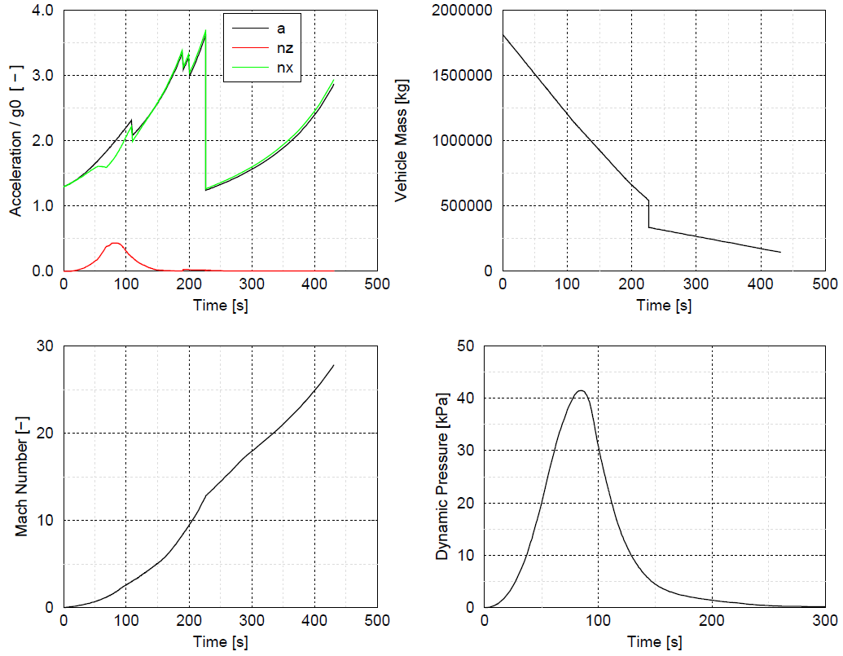

Figure ‎5‑10: Reference ascent trajectory for the SpaceLiner TSTO configuration. Part 2/2

### Ballistic Trajectory

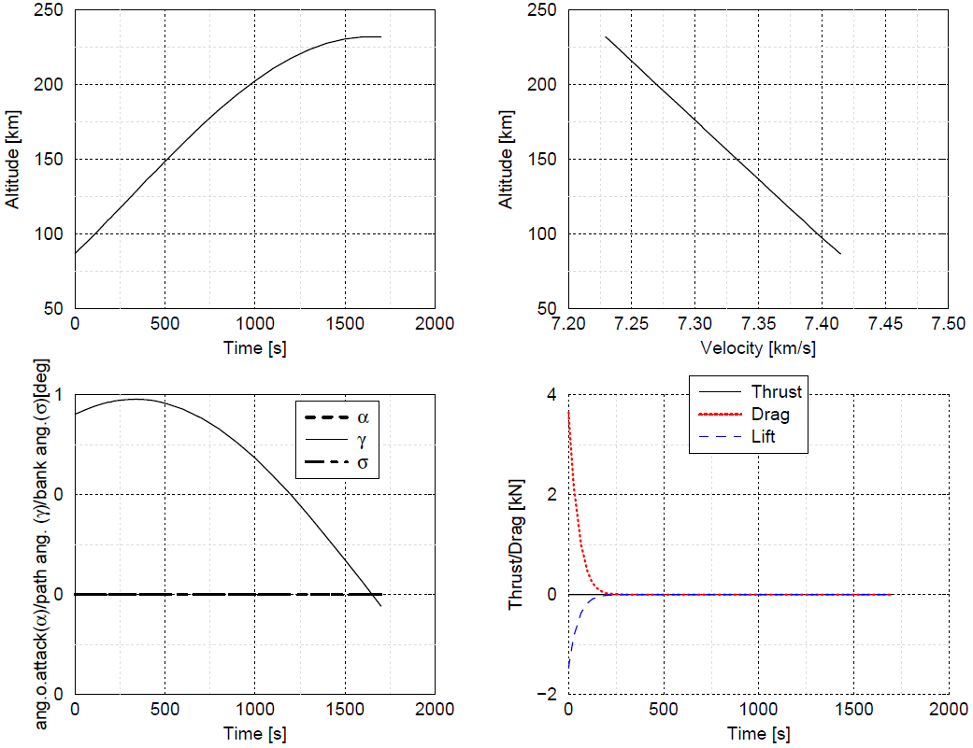

Figure ‎5‑11: Orbiter Ballistic Trajectory

### Upper Stage Trajectory

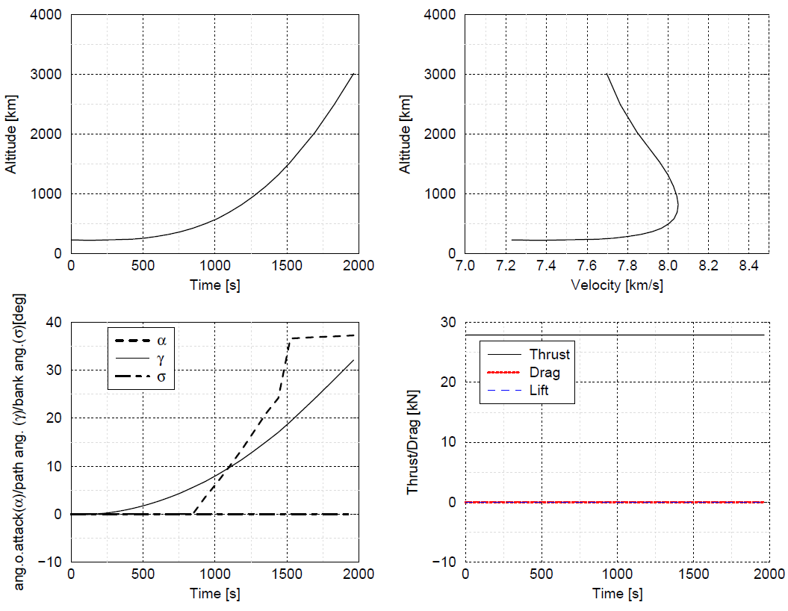

Figure ‎5‑12: Upper Stage Trajectory ½

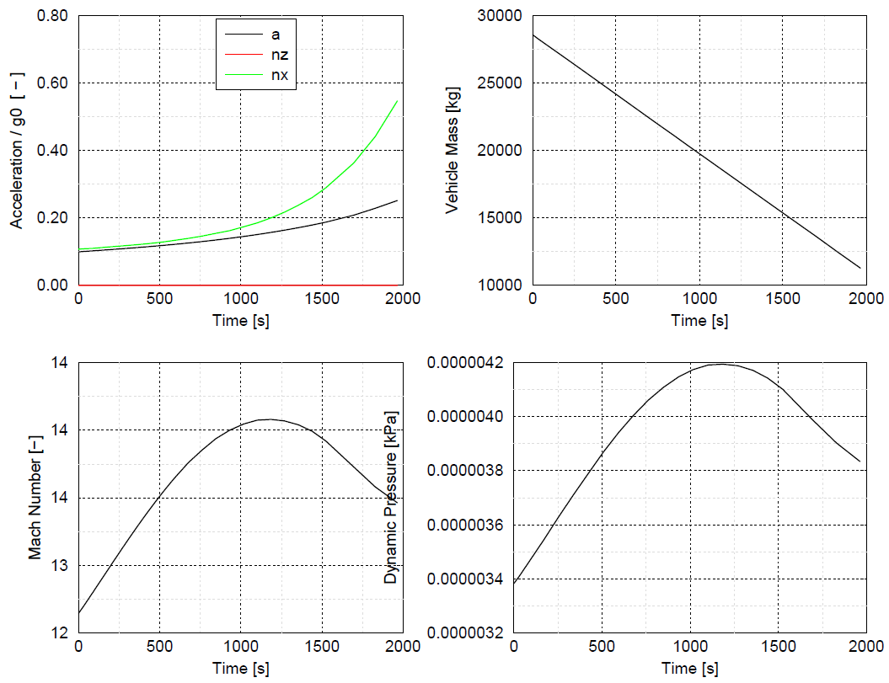

Figure ‎5‑13: Upper Stage Trajectoy 2/2

### Orbiter Descent Trajectory

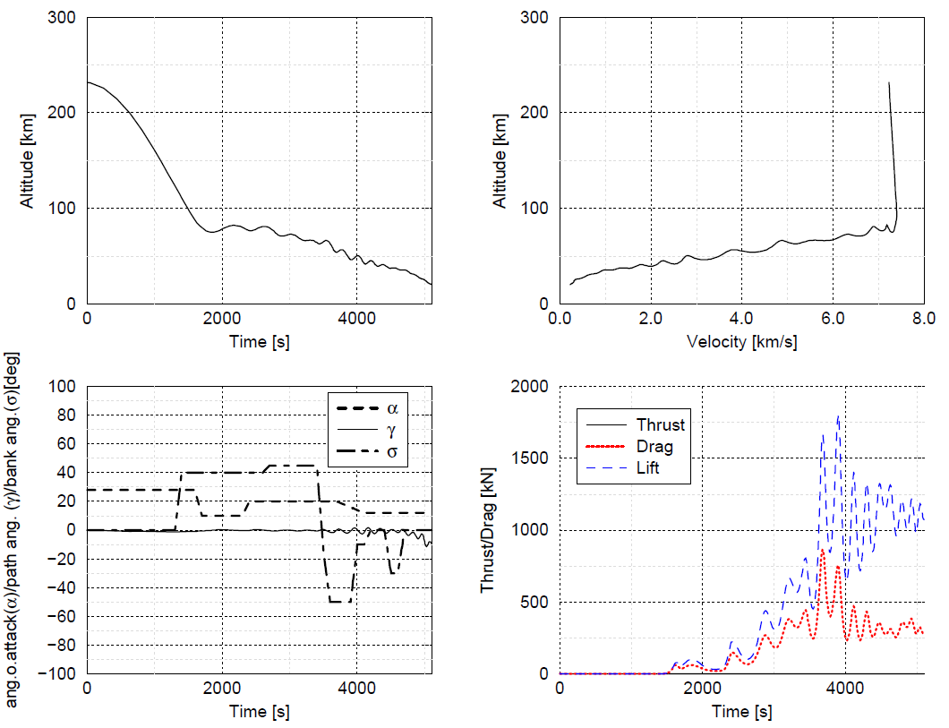

Figure ‎5‑14: Reference descent trajectory of the Orbiter of the SpaceLiner TSTO configuration. Part 1/2

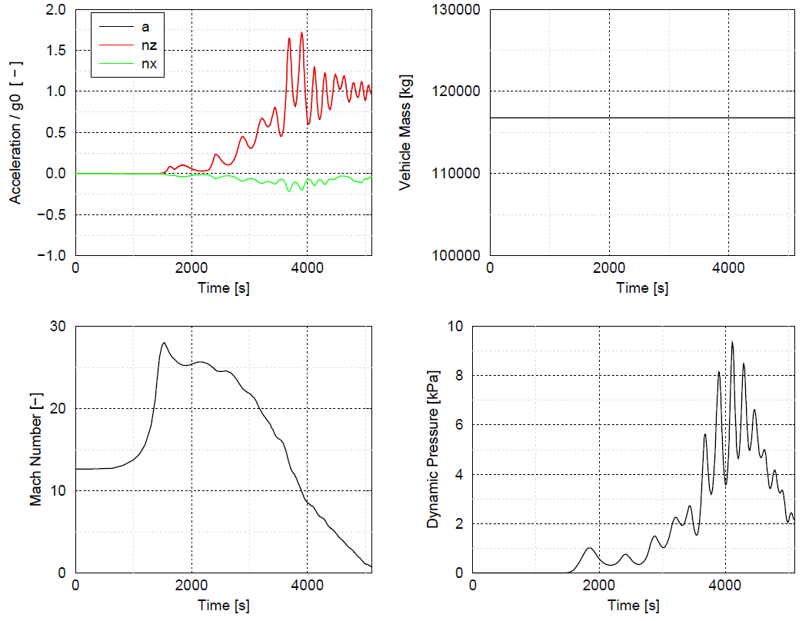

Figure ‎5‑15: Reference descent trajectory of the Orbiter of the SpaceLiner TSTO configuration. Part 2/2

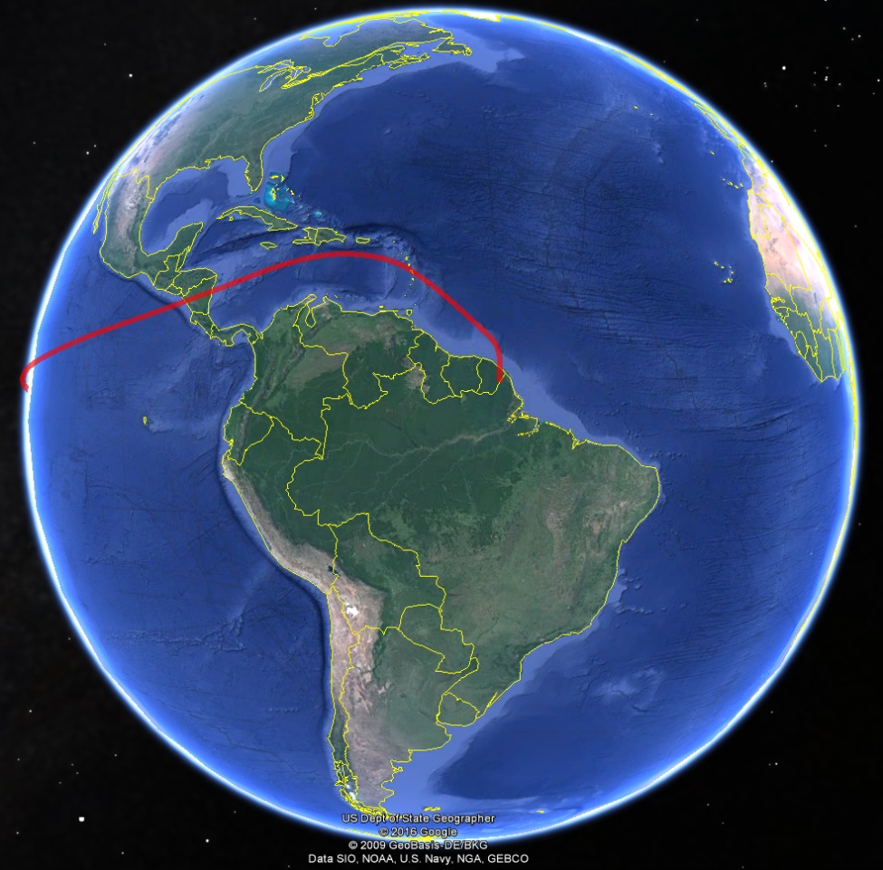

Figure ‎5‑16: Final orbiter descent phase

### Booster Descent Trajectory

The descent trajectory of the SL 7-3 TSTO booster stage presented hereafter is consistent with the latest ascent trajectory and was obtained by a 4 DOF simulation (N.B.: the orbiter descent trajectory is calculated in 3 DOF using a trimmed aerodynamic data set). Euler data for the descent of the booster stage are available for the full Mach number regime and are part of the SL7-3 aerodynamic database, ‎[SLD-5]. The approach followed in establishing the aerodynamic database is the same as was used for the SpaceLiner 7-2 aerodynamic database described in ‎[SLD-4]. It is important to note that Euler data were not available for booster descent in the SpaceLiner 7-2 aerodynamic database.

Compliance with assumptions and conditions used for the thermal protection system design of the SpaceLiner 7-3 configuration will be verified against ‎[RD-4].

The major changes in terms of booster stage aerodynamic design between the SpaceLiner 7-2 and SpaceLiner 7-3 configurations are the replacement of NACA 4-digit airfoils by NPL airfoils and a constant trailing edge thickness of 75 mm. The SpaceLiner 7-3 aerodynamic design is described in ‎[RD-5].

Euler data for SL TSTO booster stage descent are available from the subsonic to the hypersonic Mach range for the clean configuration. A large portion of the reentry takes place within the hypersonic Mach regime at high angles of attack. For this regime the Euler data have been compared to results from Hotsose. A good agreement of corrected Euler and Hotsose results with relative errors of 5 – 10 % at higher angles of attack for both lift and drag coefficients can be observed.

The inviscid Euler data are corrected to account for viscous drag by data obtained with the DLR-SART tools ProPan/PanAir and Hotsose. The effect of wingflap deflections is taken into account based on CAC calculations. The reference Area used is 461 m², the reference length is 80.5 m and the x and z coordinates of the moment reference point (center of mass of the booster stage at reentry) are 55.427 and -0.506 m respectively. This is the center of mass position for the empty stage without ascent propellant and/or reserve and residual propellant. The stage mass at reentry is 193.2 t, the pitch moment of inertia is 73605069 kg m².

The reentry trajectory of the SL TSTO booster stage is shown in Figure ‎5‑17 and Figure ‎5‑18. A comparison of PAX and TSTO booster descent trajectories is shown in Figure ‎5‑19.

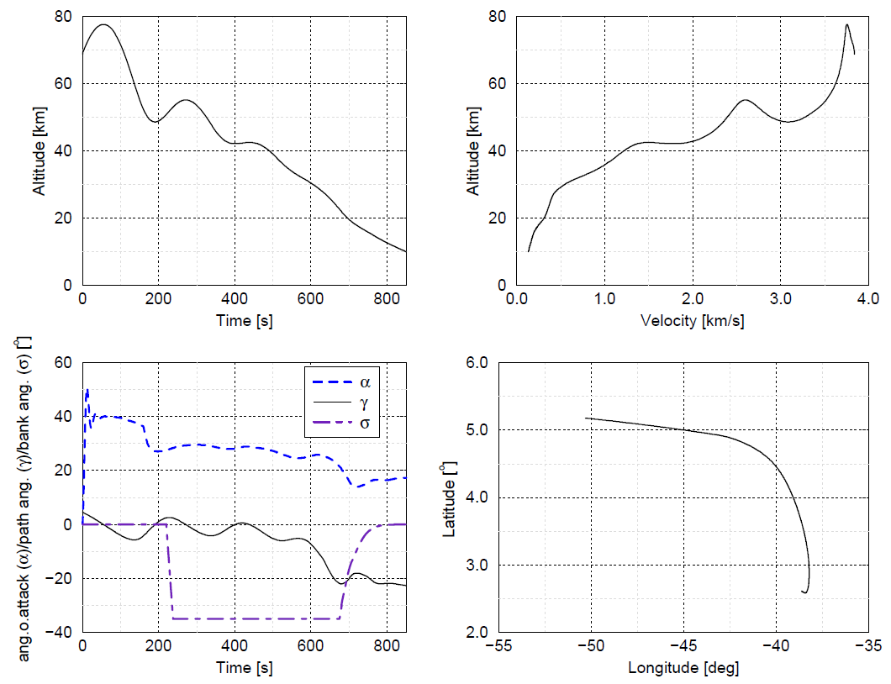

Figure ‎5‑17: SL TSTO booster descent

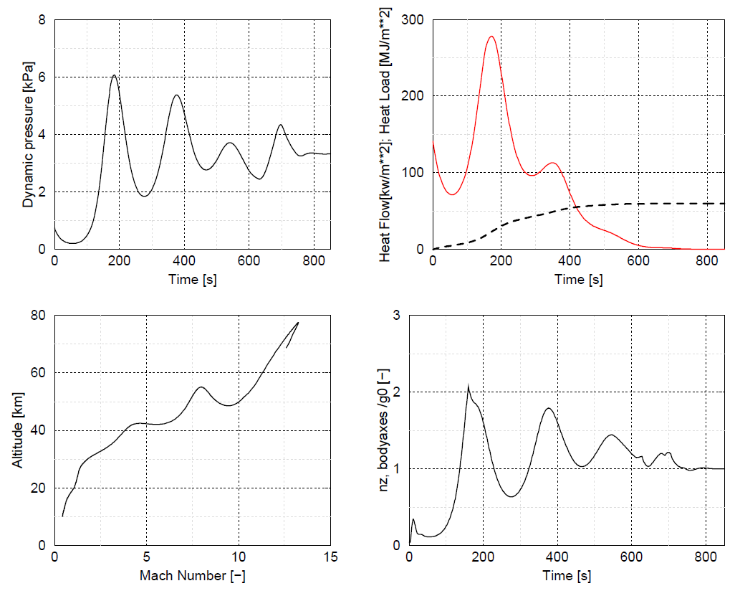

Figure ‎5‑18: SL TSTO booster descent



Figure ‎5‑19: Comparison of PAX and TSTO booster descent trajectories

#### Thermal Protection System Design

The thermal protection system mass has been recalculated based on the latest booster ascent and descent trajectories. Its compliance with the current booster mass model is verified. Two TPS designs have been considered: one using “classical” TPS materials described in ‎[RD-4] and an alternative with a significant portion of metallic TPS material.

The trajectory used for TPS mass calculation consists of three flight points of the ascent trajectory prior to booster separation and the booster descent trajectory. Mach numbers below 5 both for the ascent as well as the descent part are not taken into account.

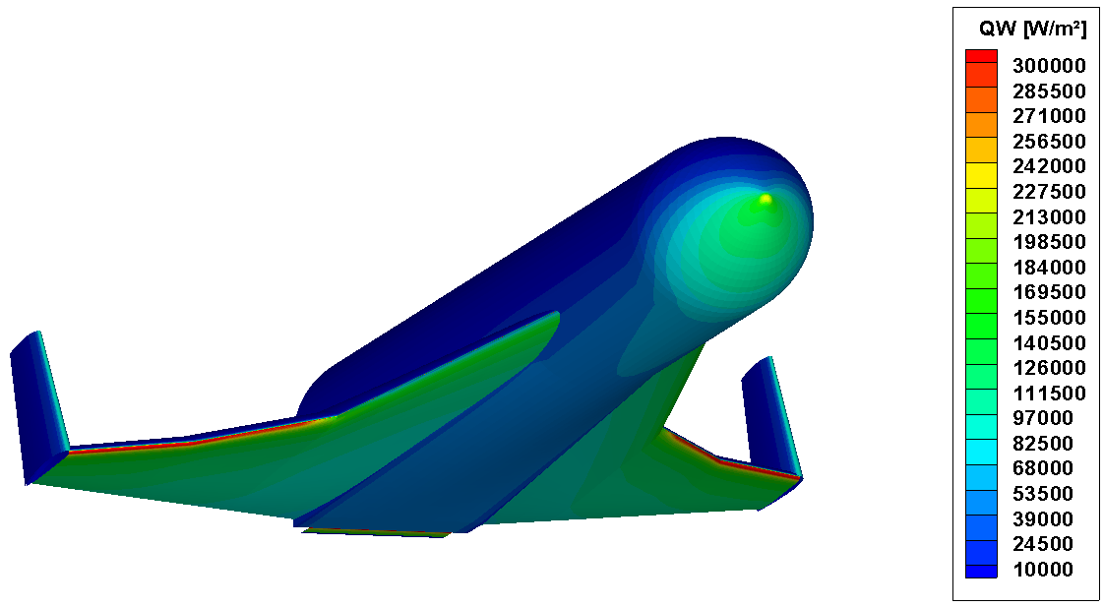

Figure ‎5‑20: Heat Flux Distribution (Ma=10, AoA=29.4 deg, Alt = 49.7 km)

The heat flux distribution for the point of maximum stagnation point heating along the descent trajectory at Ma=10, AoA=29.4 deg and 49.7 km altitude is shown in Figure ‎5‑20. Adiabatic wall has been assumed. A maximum heat flux of 214 kW/m² is calculated in the nose region which is around 77 % of the value estimated by an empirical stagnation point heating relation. **The overestimation of stagnation point heat flux by the empirical formula used by the SART trajectory tool TOSCA can partly be explained by the fact that the ratio of wall enthalpy to free stream enthalpy is considered negligible** (To be specified).The temperature distribution again for the point of maximum stagnation point heating is shown in Figure ‎5‑21.

A recalculation of the trajectory and/or the mass budget based on this TPS mass estimation results has not been done.

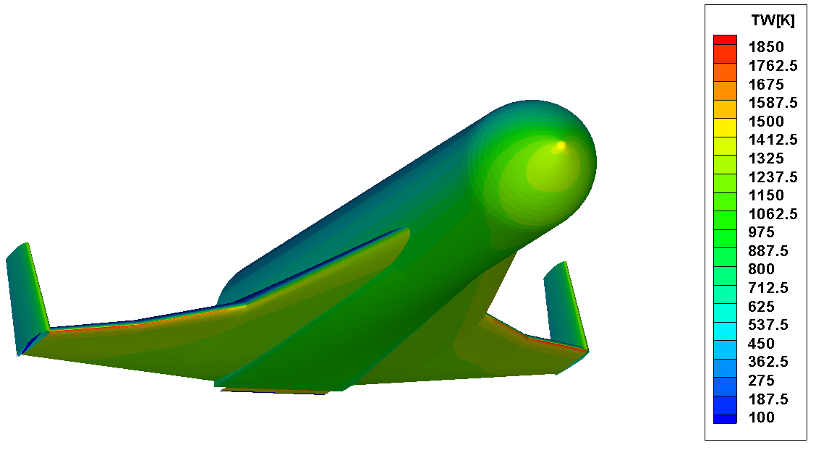

Figure ‎5‑21: Temperature Distribution (Ma=10, AoA=29.4 deg, Alt = 49.7 km)

#### Nonmetallic TPS

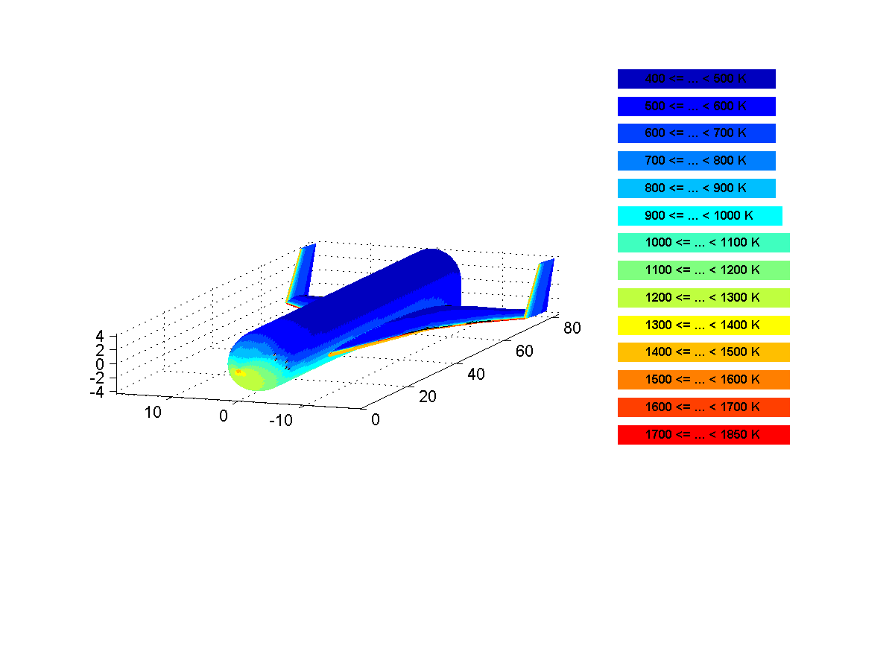

Figure ‎5‑22: Selected Temperature Areas for TPS Analysis

For the nonmetallic TPS the following materials described in ‎[RD-4] and ‎[RD-6] have been used: Felt Reusable Surface Insulation (FRSI), Advanced Flexible Reusable Surface Insulation (AFRSI), Tailorable Advanced Blanket Insulation (TABI), Alumina Enhanced Thermal Barrier Tiles (AETB) and Ceramic Matrix Composites (CMC). For the TPS analysis performed, the following temperature ranges have been assumed: 400 K – 600 K (FRSI), 600 K – 900 K (AFRSI), 900 K – 1400 K (TABI), 1400 K – 1600 K (AETB) and 1600 K – 1850 K (CMC). Temperature areas on the surface of the SL booster used for the current TPS analysis are shown in Figure ‎5‑22. A breakdown of TPS mass is shown in Figure ‎5‑23. The current mass model of the booster allocates an overall 13900 kg for the TPS. This calculation results in an overall mass of 10660 kg which shows the compliance of the updated booster descent trajectory with the current TPS design contained in the booster mass model.



Figure ‎5‑23: TPS Mass Breakdown – Nonmetallic TPS

#### Metallic TPS

As an alternative to a “traditional” TPS layout a “metallic” TPS has been investigated. A “metallic” TPS offers advantages from an operational point of view which might justify an increased TPS mass. TOP calculations are performed based on the same booster descent trajectory as is used in ‎5.2.5.2. The metallic TPS has a maximum temperature of 1300 K. Therefore for areas with higher temperatures in the nose region and on the lower parts of fuselage and wings other TPS materials have been used. For the upper part of the stage also other TPS materials have been chosen due to the low heat loads. The resulting overall TPS mass is around 17900 kg which is significantly above 13900 kg foreseen in the current model. The metallic TPS system is described in more detail in ‎[RD-6] is shown in Figure ‎5‑24. The mass breakdown between metallic and non-metallic TPS materials is shown in Figure ‎5‑25.

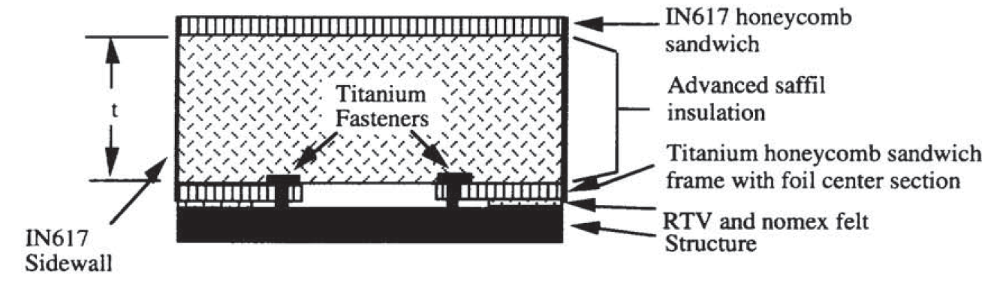

Figure ‎5‑24: Metallic TPS ‎[RD-6]



Figure ‎5‑25: Metallic TPS Mass

# Trajectory alternatives

This section investigates a variety of alternative mission profiles in which the flyover of populated areas is likely. SpaceLiner will be flying at supersonic and hypersonic speeds, potentially causing significant sonic booms at ground level. High overpressure caused by sonic booms can cause irritation to the overflown populace, or even significant damage to property, and in extreme cases, cause actual bodily harm. To avoid this, the SpaceLiner must avoid densely populated areas when flying at high speeds, or if it is not possible to route around population centres, fly at high altitudes to remove the potential effects of the sonic boom on the ground. A trajectory optimisation is developed to find a trajectory which minimises the impact of population flyover, while adhering to the strict flight limits of the SpaceLiner.

This study calculates the trajectory of each mission using optimal control theory. A control law is found which solves a generic constrained optimisation problem which is posed as follows:

$$\min{J\left(x\right)= \int_{t_{0}}^{t_{f}}{L\left(t,x\left(t\right),u(t)\right) dt }+Φ(t_{0},x\left(t_{0}\right),t_{f},x\left(t_{f}\right))}$$

Subject to the dynamic constraints of the system:

$$\dot{x}=f\left(t,x\left(t\right),u(t)\right)$$

The path constraints:

$$C_{min}≤C\left(t,x\left(t\right),u(t)\right) ≤C_{max}$$

And the boundary constraints:

$$ϕ_{min}≤ϕ\left(t,x\left(t\right),u(t)\right) ≤ϕ_{max}$$

Solving the optimal trajectory problem requires the physical problem to be transcribed into a form which is solvable by a generic optimal control solver. This study utilises the pseudospectral method of transcribing the optimal control problem, which is then solved using a sequential quadratic programming (SQP) solver. The pseudospectral method, or global orthogonal collocation method, approximates the state and control variables as polynomials, collocated at specified nodes. More information on the pseudospectral method can be found in refs {REFXX}. To solve the optimal control problem, the proprietary pseudospectral solver GPOPS-2 is used. GPOPS-2 takes inputs of the vehicle model, cost function, and system bounds, and computes a minimum cost solution. The simulation is performed in a 6 degree of freedom geodetic rotational reference frame {REF}.

The physical dynamics of the system in GPOPS-2 are defined as ‘states’. These states are the time-variant physical characteristics of the system (altitude, velocity, mass etc.). The vehicle model in GPOPS-2 takes an input of the current state guess, and outputs the corresponding time derivatives of the states. GPOPS-2 then solves the optimisation problem, so that the derivatives of the approximated states are equal to the time derivatives calculated by the vehicle model.

The cost function used to drive the optimisation is:

$$C=\int_{t_{0}}^{t_{f}}{\frac{\left({alt}_{target}-alt\right)}{c_{1}}P(lon,lat,alt)+\frac{\dot{Q}}{c_{2}} dt}$$

Where $P$ is the interpolated population density, and $c_{1}$ and $c_{2}$ are weighting factors. These weighting factors have been used to scale the problem for numerical stability, and to weight the parts of the cost function. The heating rate cost has been weighted so that it is negligible compared to the population density cost, when flying over populated areas. When there is no population flyover, the heating rate is then minimised.

A 2020 estimated population density distribution map is used as the population density cost factor. This is imported as a GeoTiff at 2’30” resolution. The population density cost is scaled by altitude so that the population cost goes to 0 at 80km altitude, and increases linearly as altitude decreases. This drives the optimisation to keep the altitude of the SpaceLiner as high as possible over populated areas, if flying over population is unavoidable.

The heating rate is limited to 1.3MW/m2, the maximum heating flux limit of the SpaceLiner, which is based on the observed maximum heating rates in the reference Australia-Germany trajectory. The descent portion of the trajectory is limited to negative flight path angle, to remove the possibility of ‘skipping’ manoeuvres which may be detrimental to passenger comfort.

## Reference Mission AUS-EUR

The reference mission of Rockhampton-Germany is calculated in GPOPS-2, in order to compare the optimised trajectory to the existing TOSCA and SLEG simulations.

### Comparison with TOSCA & SLEG

A flyover of the Solomon islands is avoided. The optimized trajectory also chooses a more northerly trajectory, flying over a sparsely populated area of Siberia rather than Canada, reducing population flyover.

Integrated heat load is decreased by 18.7%.

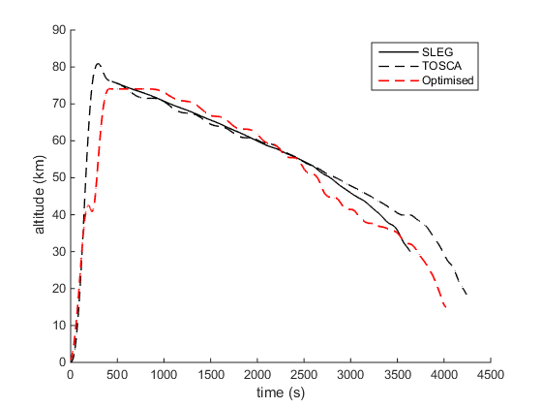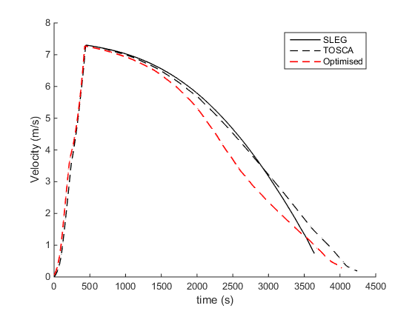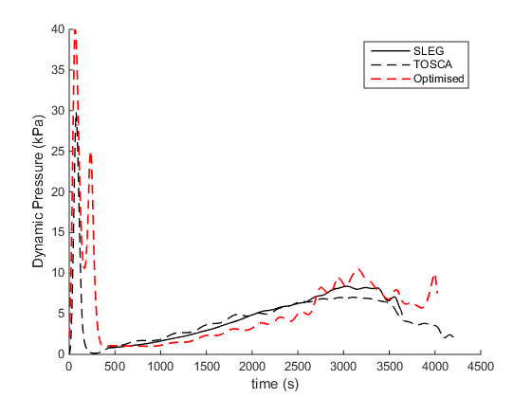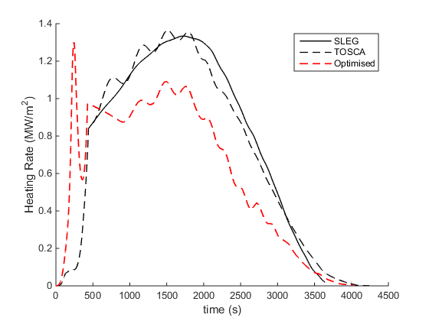

## Mission ASIA-EUR

A launch site near Suzu, in the Ishikawa Prefecture of Japan, has been chosen for an Asia-Europe mission. This launch site is within 350km of both Tokyo and Osaka, and 100km from Kanazawa, which is serviced by the high-speed Shinkansen rail system. The Suzu launch site allows for a launch trajectory which avoids large population centres when flying over mainland Asia.

### Japan-Germany

The optimised minimum population flyover trajectory from Japan to Germany is shown in Figure REF. The optimised trajectory flies over eastern Russia, however, the settlements overflown are small towns, with no overflight of significantly large cities. The maximum overpressure over Khabarovsk Krai of Russia is 10.59pa, well within the acceptable margin of population disturbance {REF}.

-Fuel Remaining 6.27 tonnes.

-Total Heating

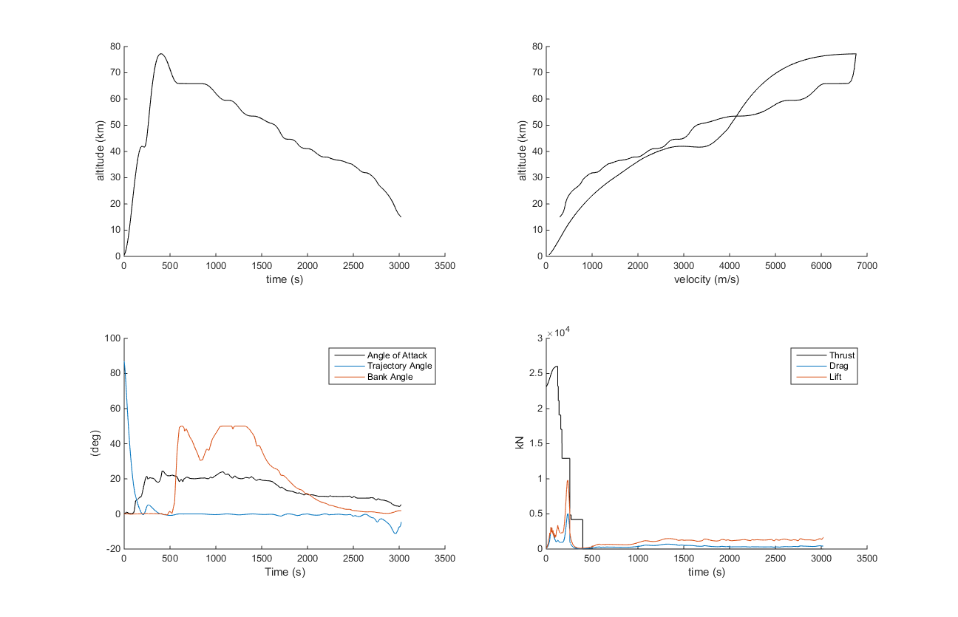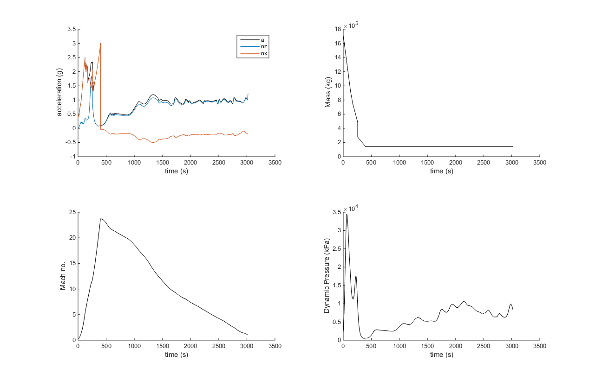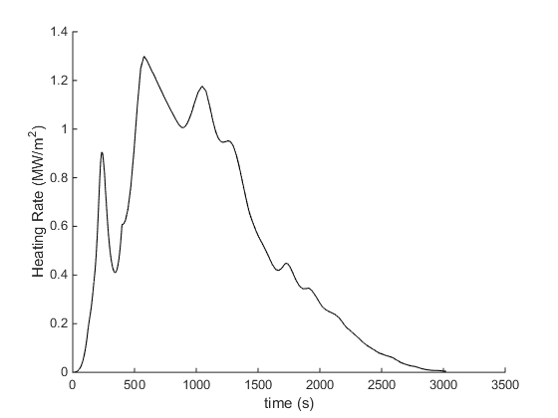

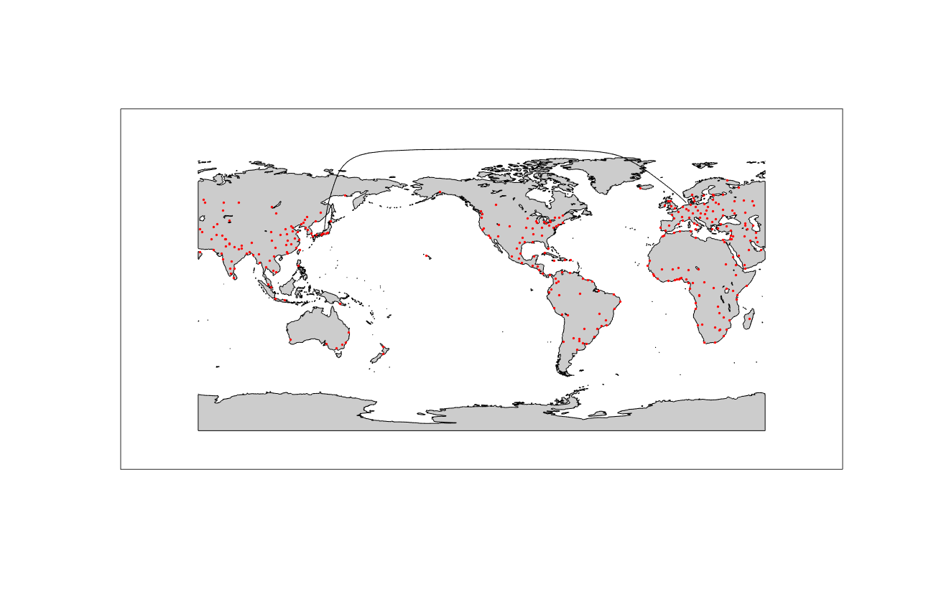

### Germany-Japan

The mission from Germany to Japan is constrained to end at an approach point above the Sea of Japan. This is done to allow the optimised trajectory to avoid a flyover of Japan. It is assumed that at the end of the optimised trajectory, the SpaceLiner has sufficient altitude and velocity to manoeuvre for a landing close to Suzu, Japan, 550km away.

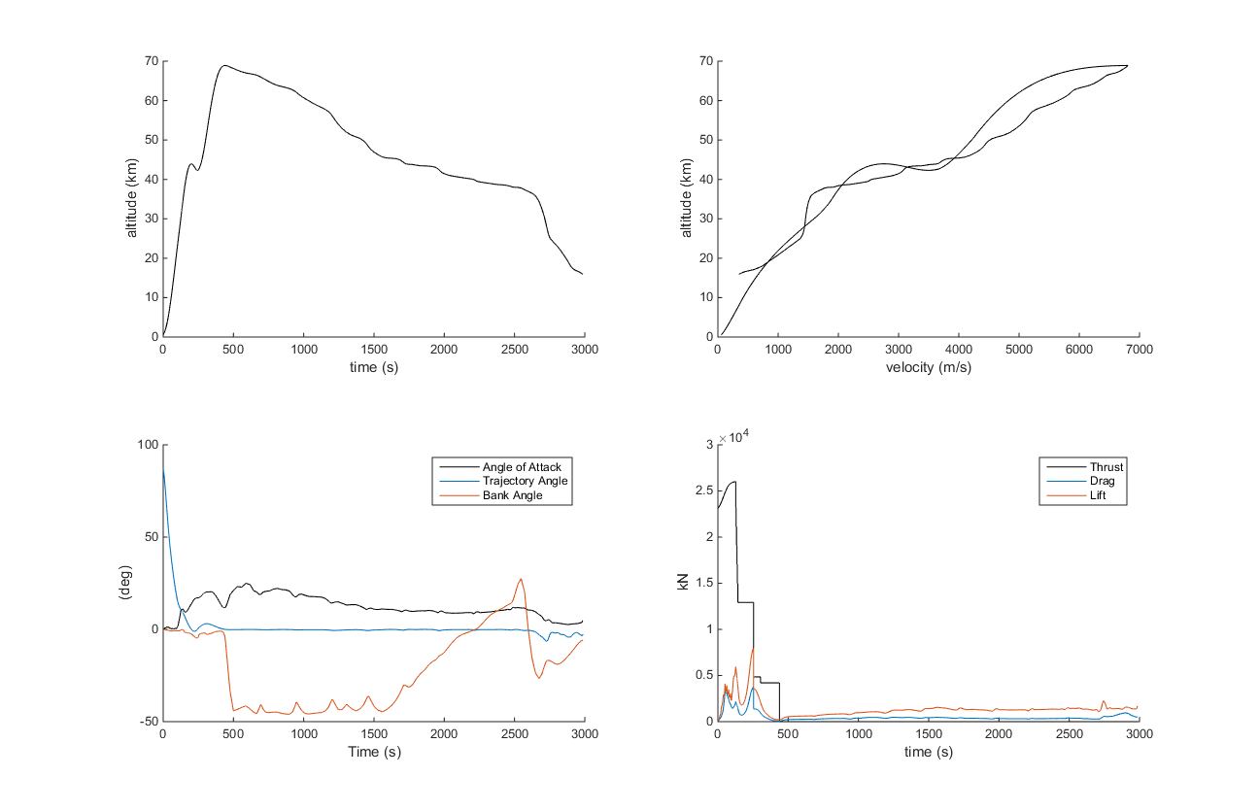

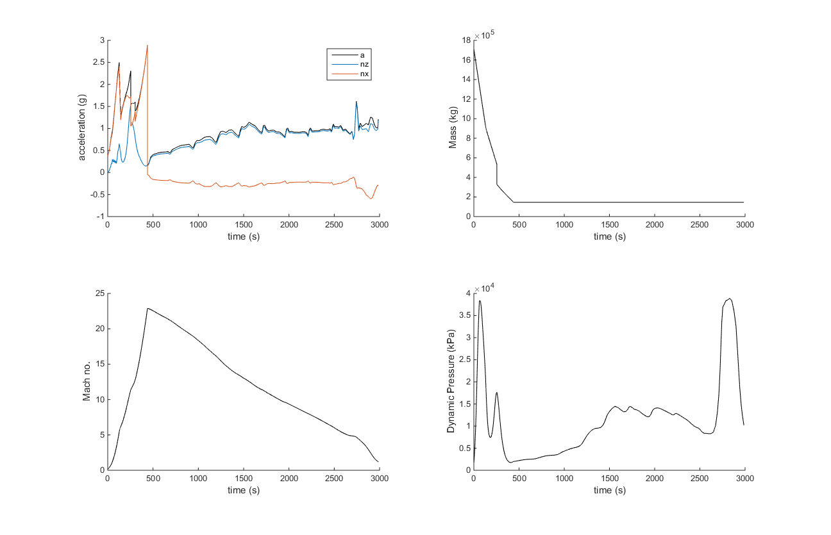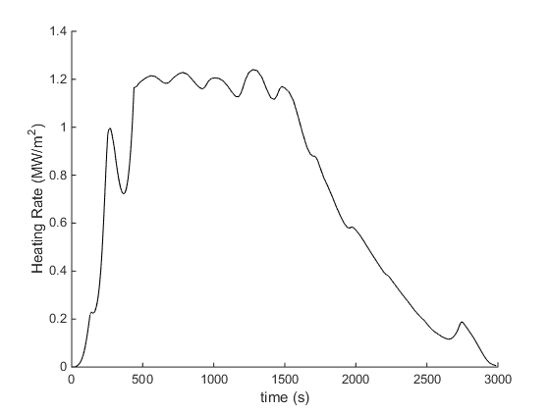

## Mission AUS-US

A mission between Australia and Florida must necessarily fly over Mexico or Central America.

### Rockhampton to Florida

25.85 tonnes of fuel remaining.

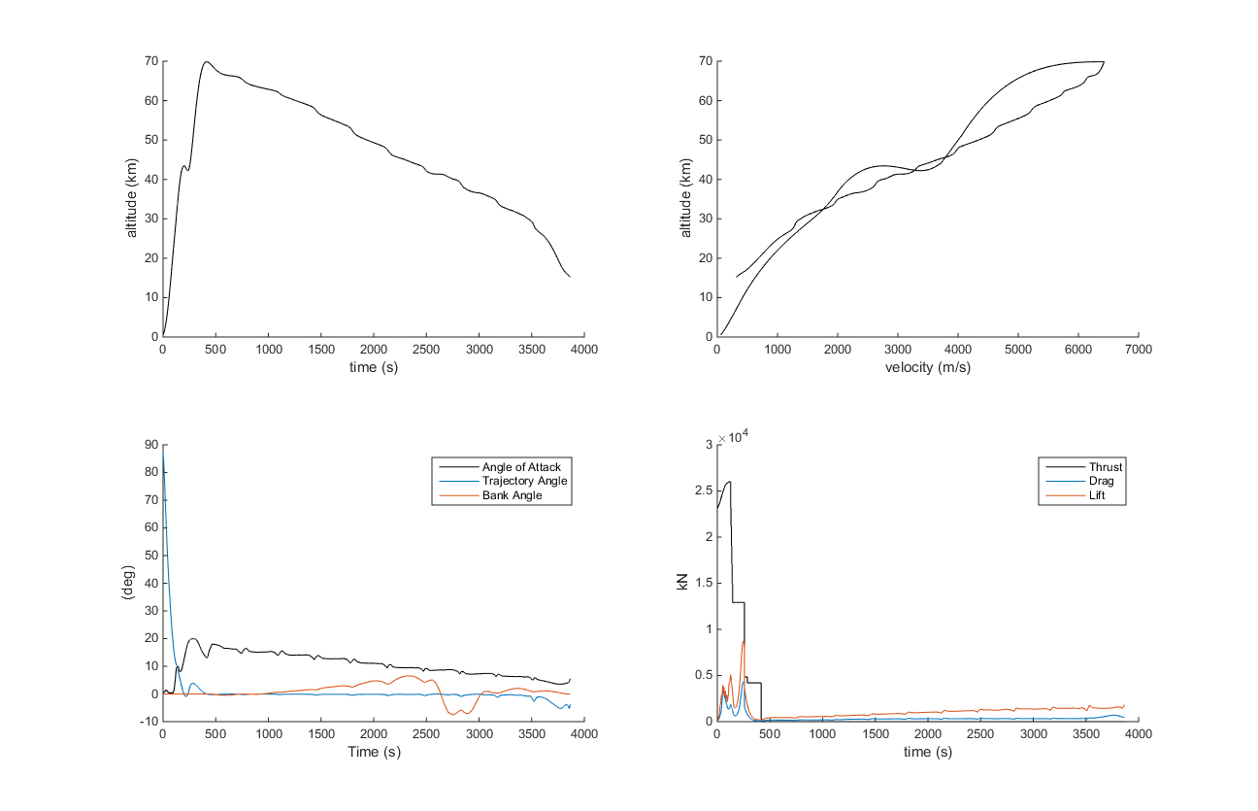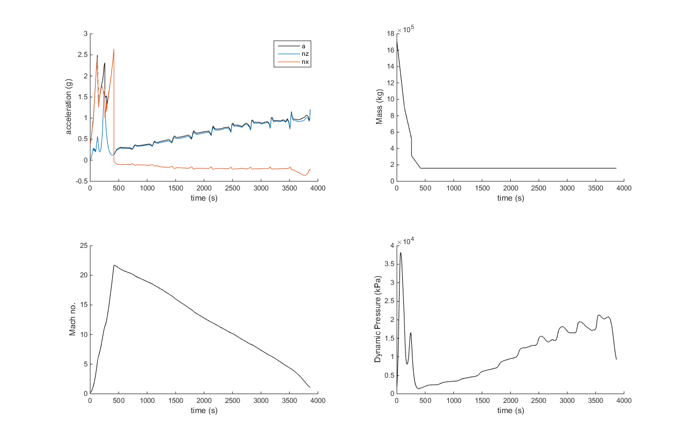

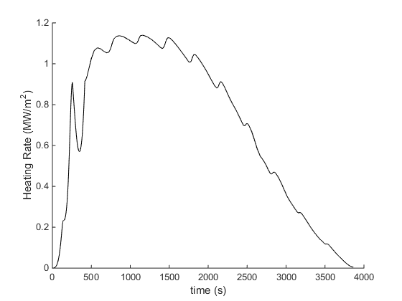

### Florida to Rockhampton

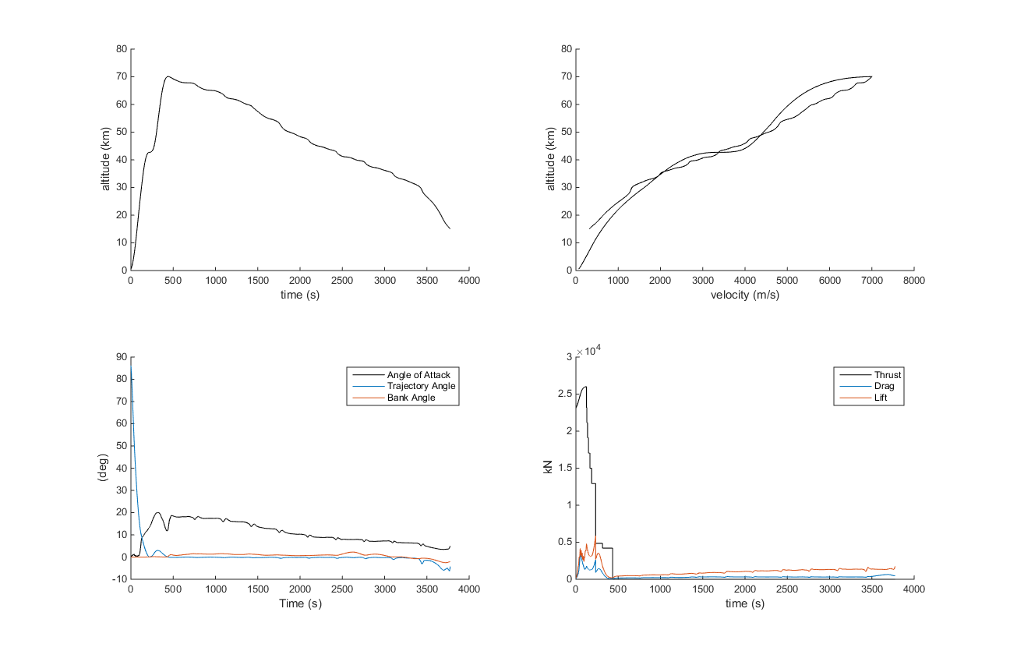

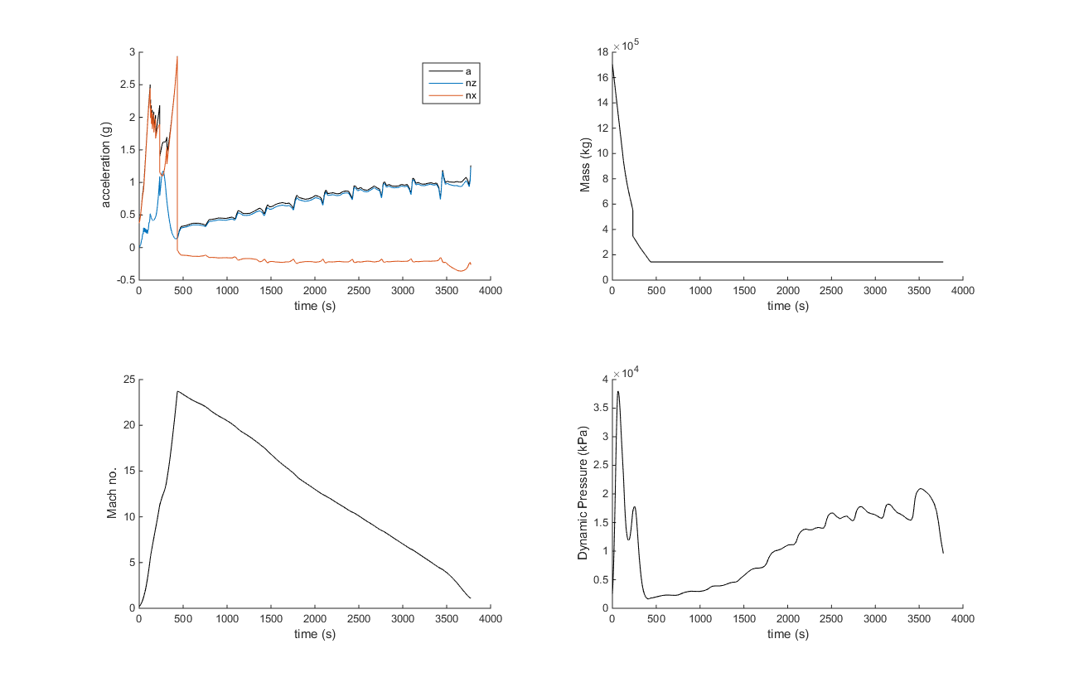

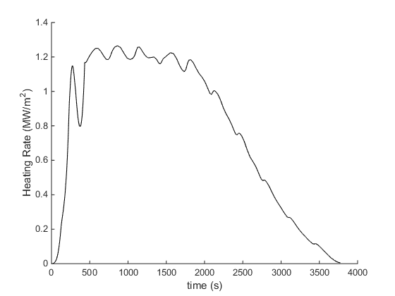

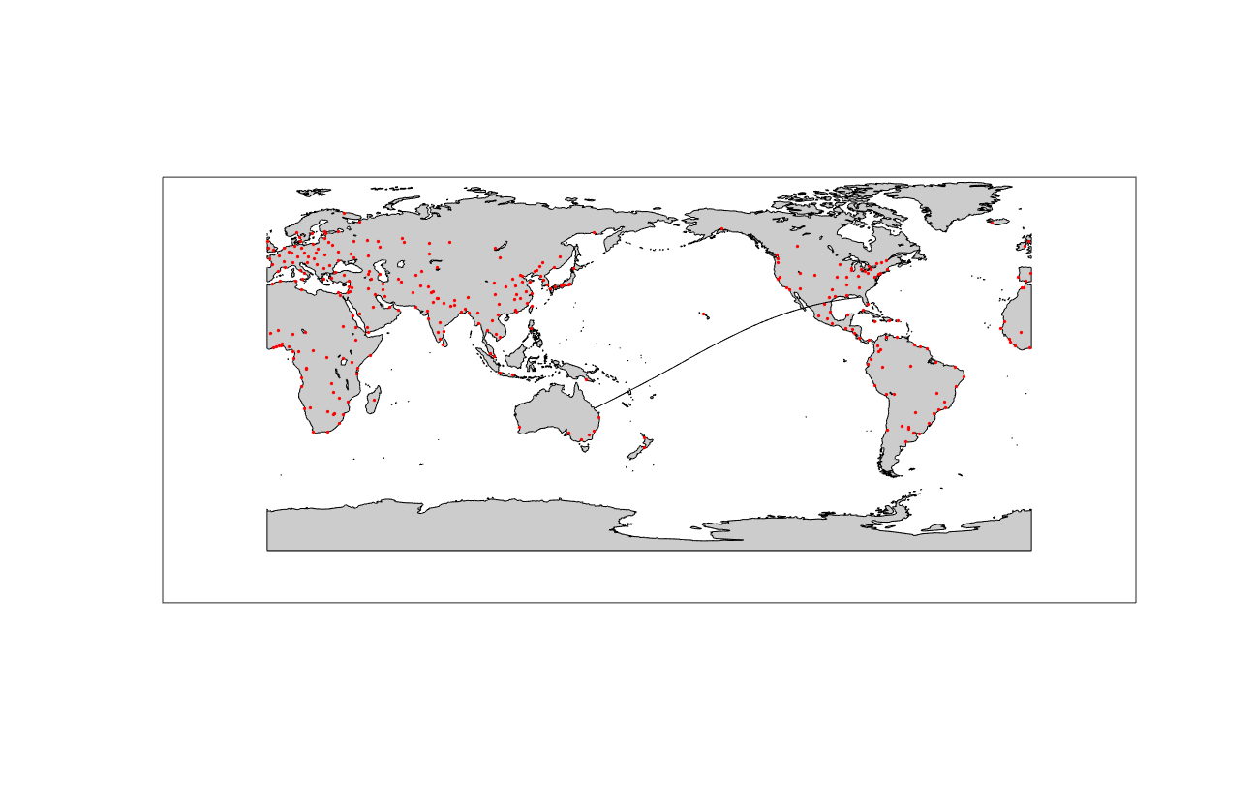

# Description of subsystems

The following table lists all major Subsystems and the documents where a detailed description can be found. While many of these are not SpaceLiner Subsystem Specification documents over the course of Phase A iterations all changed subsystem designs will be documented within a SpaceLiner document.

Table ‎6‑1: Overview of subsystem documents

|  |  |
| --- | --- |
| Structures |  |
| Landing Gear |  |
| Attachment Structure |  |
| Rescue Subsystem |  |
| Passenger Cabin |  |
| Rocket Main Propulsion | SL-SSS-SLME-SART-00040-1/0 |
| Propellant Supply System | SL-SSS-PSS-SART-00039-1/0 |
| Reaction Control Engines |  |
| Stage Separation Motors |  |
| Active Cooling Systems |  |
| Passive TPS |  |
| Actuators |  |
| Power |  |
| Avionics |  |
| GNC |  |
| Communications, Telemetry |  |
| HMS |  |
| Aerodynamics AEDB | SL-SS-AEDB-SART-00037-1/0 |
| Aerothermodynamics |  |
| Thermal Management |  |
| Business case & costs |  |